System Design Document

For

Cross Border Trucking Business – CBTB
(Phase I – Full Container Load)
(Comment)
Confidential

Author : HutchTech Resources Limited

Revision : 1.0
Date : 2001.07.16
Contents
1. Introduction 5
1.1 Purpose of system 5
1.2 Domain Abbreviations 5
1.3 System Objectives 5
1.4 Business Benefit 5
1.5 References 5
1.6 Overview 6
2. System Architecture 6
2.1 System Architectural design 6
2.1.1 Physical Components 6
2.1.2 Physical Components 7
2.2 Components Deployment Details 8
2.2.1 2.2.1 Web Tier Components 8
2.2.2 Application Tier Components 9
2.3 Entity Beans details 10
2.3.1 Files Included with Entity Beans 10
2.3.2 Base method Included with Entity Beans 10
2.4 Session Beans details 11
2.5 Architectural Compliance 12
2.5.1 J2EE 12
2.5.2 JDBC 12
3. System Design Description 12
3.1 Introduction 12
3.2 Object Model 12
3.2.1 Class Diagram 12
3.2.2 Package 17
3.2.3 Method Description 23
3.2.4 JSP Desciption 29
3.3 Dynamic Model 32
3.3.1 Post Delivery Request 33
3.3.2 Match 34
3.3.3 Generate Invoice 36
3.3.4 Generate Statement 37
3.4 Message Query 38
3.4.1 Summary: 38
3.4.2 Request and Design 39
3.4.3 Work flow chart 39
3.4.4 Program specification: 40
3.4.5 Classes specification: 40
3.5 Security Control 40
3.5.1 Summary 40
3.5.2 Class Description 41
3.5.3 Some module of Security Control 41
3.6 Report 44
3.6.1 Summary 44
3.6.2 System Architecture 44
3.6.3 Format Design 44
3.6.4 Program Design 44
4. Database 45
4.1 DataBase Diagram 45
4.1.1 Company Profile 45
4.1.2 Master data 46
4.1.3 Delivery Request & Invoice 47
4.1.4 Truck Capacity & Statement 48
4.2 DataBase Table Structure 49
4.2.1 Table ADDITIONAL_FEE 49
4.2.2 Table CARGO_CATEGORY 49
4.2.3 Table CITY_DATA 49
4.2.4 Table COMPANY_PROFILE 49
4.2.5 Table CONTAINER_TYPE 50
4.2.6 Table DELIVERY_PRICE_FEE 51
4.2.7 Table DELIVERY_REQUESET_ADDFEE 51
4.2.8 Table DELIVERY_REQUEST 51
4.2.9 Table DELIVERY_TIME 53
4.2.10 Table DELIVERY_TIME_SLOT 53
4.2.11 Table DEPOT_DATA 53
4.2.12 Table DOCUMENT_NEED 53
4.2.13 Table DOCUMENT_RECEIVING_STATUS 54
4.2.14 Table INVENTORY_DAILY 54
4.2.15 Table INVOICE_DATA 54
4.2.16 Table INVOICE_DETAIL_DATA 55
4.2.17 Table INVOICE_PAYMENT_HISTORY 55
4.2.18 Table MATCH_CAPACITY_REQUEST 56
4.2.19 Table MATCH_FEE_DETAIL 56
4.2.20 Table PACKAGE_UOM 56
4.2.21 Table REASON_CODE 57
4.2.22 Table SHIPPINGLINE_CONTAINER 57
4.2.23 Table SHIPPING_LINE 57
4.2.24 Table STATEMENT_DATA 57
4.2.25 Table STATEMENT_DETAIL_DATA 58
4.2.26 Table SYSTEM_PROCESS_PARAMETER 58
4.2.27 Table TRADING_PARTNER 59
4.2.28 Table TRAILER_TYPE 59
4.2.29 Table TRANSACTION_CODE 59
4.2.30 Table TRANSACTION_LOG 60
4.2.31 Table TRUCKER_DATA 60
4.2.32 Table TRUCK_CAPACITY 61
4.2.33 Table TRUCK_CAPACITY_ADDFEE 61
4.2.34 Table ZONE_DATA 62
5. Appendix: 62
5.1 Development Tools and Technologies 62

General Comments
- Generally speaking, the System Design Document is not detail enough. Many functions and components are only listed without any explanation or description. It only provides partial Structural view (Class diagram), a very brief behavior view (sequence Diagram of 5 main workflow), and an incomplete implementation view (some component and package diagram) of the system. That is to say, it only provide some “what” but few “how” of the system. We cannot fully understanding the system by the document
- Mix the traditional (workflow) and UML approach. So that Different views of the System are not clear enough. Classes diagram and Sequence diagram is used in some session but not complete. Different approach was used in the EJBs part and others.
- The document does not cover all areas of the System. Some critical area is not covered. Including the following
  - Full details of TL and Transport Link Integration, but only the message queue part.
  - How the components interact with each other. That is what and how JSPs, helper classes, Java bean and EJB interact with each other. It just shows the “Dependencies” of the EJBs and the object called “Web Operator”, as well as the high level Relationships between JSP and Session.
- The document does not contain any Design pattern or Framework for the system (such as MVC).
- The document does not contain enough information on how to handle the exception and error in the system.
- The document does not contain any information about system Architectural Goals and Constraints
- The document does not cover any business method of the EJBs.
- Package, classes, interface and method listed without any description.
- JSP was listed with component view but without any description.
- From my understanding, the database schema is not an updated one and the entire security tables are missed. The database schema and relationship are also listed without any description and discussion.
- From the testing, we found some “hard code” problem in the system. Such as “99999” for “Hong Kong” in the city. However it is not covered in the document.

Introduction

Purpose of system
The Cross Border Trucking Business (CBTB) application aims to provide internet-enabled e-marketplace for shippers & cargo owner to address the issue faced by customers and service providers. At present, trucks going to China or to Hong Kong often in empty container traffic that leads to inefficiency problem.

(The system name are now changed to “Transport Link”, the document also used it in session 3.4 but not in the case in others, it is important for the document to be consistent)

Domain Abbreviations
The following abbreviations are used throughout the document.
- CBTB - Cross Border Trucking Business
- TL – Transact Link : The upper web site system
- MQ – Message queue : one product provided by IBM
- J2EE - Java 2 Platform, Enterprise Edition

System Objectives
The CBTB is a Web based system made up of front user subsystem and backend operator subsystem.

The front subsystem provide trucking company to post and update trucker capacity, view truck capacity, view delivery request, maintain trucker information, view tariff; and provide shipper to post and update delivery request, view truck capacity, view delivery request, matching between truck capacity and delivery request, maintain trading partner, view tariff;

The backend subsystem provide system operator to maintain company registration information, maintain truck capacity, maintain truck capacity, user identification, matching, Billing (generate and print invoice, service report, payment), maintain master data, generate management report, update inventory .

Business Benefit
Provide a backend system to run CBTB daily operation and optimize resources utilization in call handling and truck matching service offering as well as to deliver our committed customer service level to trucking companies/truckers and shipper.
To facilitate the matching on web between trucking company &shipper and provide a easy and convenient interface for trucking & shipper to search for truck capacity and delivery request correspondingly.

References
“Business Requirements Specification for CBTB Version 1.4”
“CBT Technical Requirements Specification”
“Functional Requirement Specification For CBTB version 1.5 ”

Overview
(NO Content!?)

System Architecture

System Architectural design
This section presents the physical and logical components of the CBTB. The physical component shows the network configuration and each server’s responsibilities in the system. The Logical component presents the logical partitioning of CBTB.

Physical Components
The CBTB consists of four main components, namely: client browser, Web server, application server ,database server. and two assistant components ,namely: MQ server, Jreport Server. The following figure shows the overall architecture:

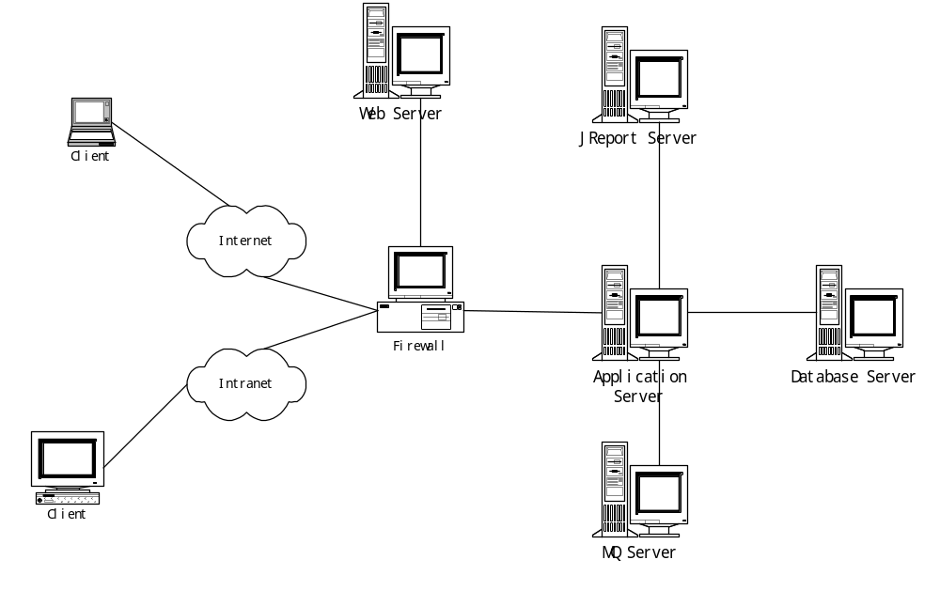
The following table summaries the responsibilities of each component and the software to be installed:

Component | Responsibilities | Software to be Installed
Client Browser | Act as the user interface container where user can communicate with server using Hypertext Transfer Protocol (HTTP) | Windows 98/ Windows 2000 with Internet explorer
Web Server | The web servers to serve HTML, JSP pages and images.  Dynamically generate Web pages according to different requests.. | Weblogic Web Server 5.1  JDK 1.2.2
Application Server | Act as s EJB service provider that handles request. Business Logic is encapsulated in EJB objects and Java Bean classes.  Provide database connectivity using JDBC | Weblogic Server 5.1  JDK 1.2.2
Database Server | Provide a stable storage for system information | Oracle Database Server 8i
Jreport Enterprise Server | Provide Java report servers for enterprise applications  Provide database connectivity using JDBC | JReport Enterprise Server  3.1.2
IBM MQSeries | Provide a Message Queue to exchange data between multi-system . | IBM MQSeries 5.0

Physical Components (why use same name with session 2.1.1, if discuss the same thing one session should be enough, otherwise please use the other name)

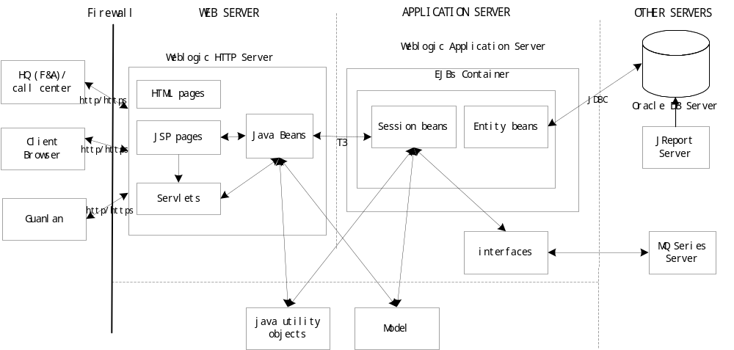
In system architecture view, LINE CBTB project is typical multi-tiers Internet application. It adopted J2EE compliant features that include Web container (runs on Web Server), EJB Container (runs on Application Server) and EIS (DB Server, MQSeries and JReport server ).

J2EE is components based system. WebLogic Application server can be developed in series components and deploy the component on it’s run time environment such as web container and EJB container.

Components Deployment Details
WebLogic Application Server is J2EE compliant Server. J2EE is component based architecture. I.e. the system was developed in series components that should be deployed on different run time environments. This paragraph is used to illustrate all details that developed components. Mainly describe JSPs, Servlets and Java Beans that deployed in web tier and EJBs, Java Objects and Interfaces that deployed in application tier components.

The Component of web container and EJB container was discussed separately but the relationship and how they interact with each other is omitted. It only shows the general concept but does not contain the details of the components; it doesn’t even contain the list of system components. In my opinion, it should be the real content related to the system Deployment, otherwise it should not name as “Details”.

2.2.1 Web Tier Components
Weblogic http server: The WebLogic http Server offered one web container (J2EE 1.2.1 Specification), a web components run time environment. It supports J2EE JSP 1.1 standard, Servlet 2.2 standard and Java bean (supported by JSP specification).
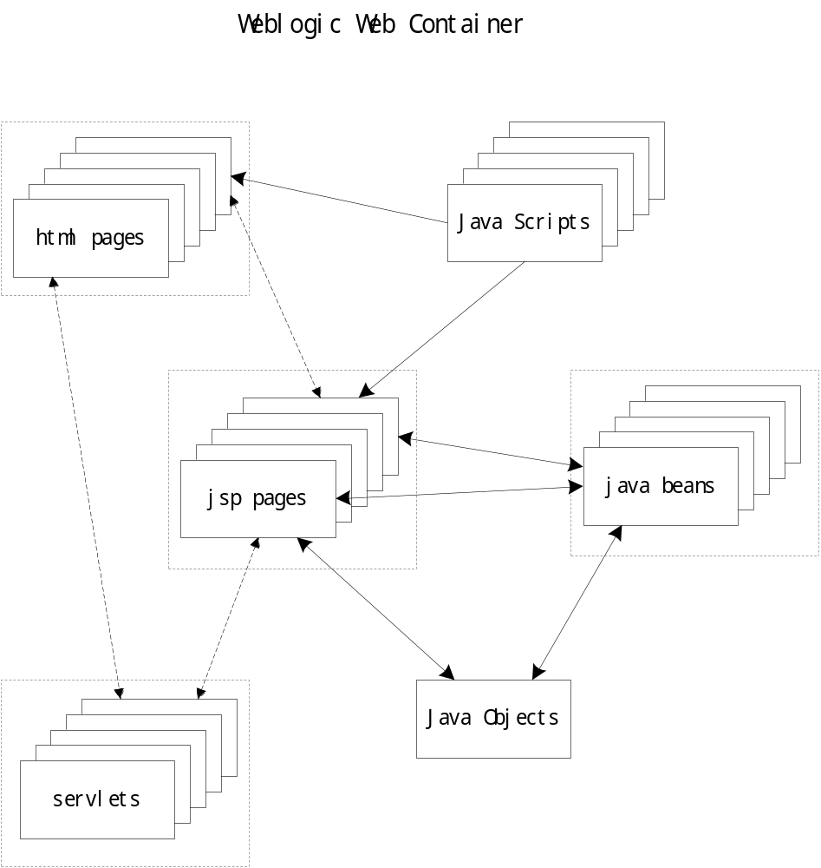
- Java Beans: We defined a series Java beans to keep and encapsulate the information that got from jsp pages into Java objects, it also talks with EJBs to finish the business logic. ( what are the “Java beans” ? )
- JSP pages: We developed a lots of jsp pages to collect information from customers and put it in Java beans, it also get information from Java beans and display the content of the Java beans. . ( what are the “JSP” ? )
- Html pages: Some html pages should be developed to presentation the static information of the web site. (What are the “Html”? Have no information on the document!)
- Servlets: some servlets should be developed to control the pages logic follow or jump around. Servlets is good option to VCM (MVC?) web application architecture, but it is not the only way, because jsp pages also does same work after it was compiled by jsp compiler. (So, what are the “Servlets”? so how, how much and when MVC used in the System? As stated “it is not the only way, jsp pages also does same work…”. By the way, when the system and what components will use jsp as an control ? What is the drawback and constraint of the system with this approach?)
- Java scripts: Some Java script should be developed to validate the fields that by customer filled. Java scripts should not be used to logic control although it can be, because some browser don’t support Java script control.
- Java Objects: we defined some Java objects that invoked by jsp pages or Java bean to generate some display formats or some file format such as pdf files ( what are they?)

Application Tier Components
Weblogic application server: The Weblogic Application server offered a EJB container (J2EE 1.2.1 Specification), a EJB run time environment to execute all EJB object. It supported EJB 2.0 standard that include Session Bean and Entity Bean but no Message Driven Bean (The EJB 2.0 should not be used as it is in “Proposed Final Draft 2” only, although Weblogic 6.0 support some of it in the specification, please clarify whether the ejb used EJB 2.0 or not, and if used which part are used) . EJB container support container transaction control, but in this project we considered the system should run in parallelism EJB instances rather than cluster, so we should use bean transaction control. (the document just mention user bean transaction control (BMP-Bean-Managed Persistent?) but does not contains any details information and how it will work with the parallelism)

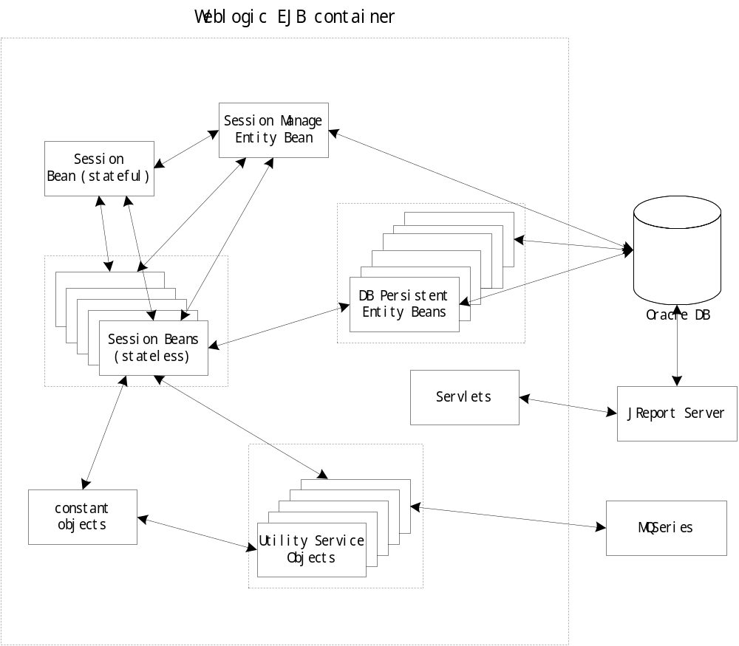

- Entity Beans: we should develop a series Entity Beans to persist the data store that coexist with data base table. I.e. one Entity bean matches one DB table row. Also we defined one Session manage Entity bean to keep all customer action tracking. ( Some Details information should be given here to clarify what are the Entity Beans in the system.)
- Session Beans: We should develop a series session bean to handle all business logic. They should be invoked by Java bean, servlets or jsp pages with it’s remote methods. The session beans include stateful session bean and stateless bean. The stateful session bean is customer session bean, this session bean should invoke other stateless session bean to finish business logic that should have transaction control. Stateless session bean should invoke entity beans to access database, session bean formal is stateless. ( So, more details should be provided?)
- Interfaces: We defined some interfaces to talking with message queue, log service or Ldap service objects. (What are the interfaces and how does it work?)
- Java utility objects: We defined some Java objects to help EJBs to generate some basic objects such as customer info, some data format such as date-time format and some constants that should be used in this project. (What are they? Which EJBs will use/call them?)

Entity Beans details
The entity bean component contract for bean managed persistence is the contract between an entity bean and its container. It defines the life cycle of the entity bean instances and the model for method delegation of the client-invoked business methods. The main goal of this contract is to ensure that a component using bean managed persistence is portable across all compliant EJB Containers.

Files Included with Entity Beans
The entity bean class :is a Java class that models persistent data. An entity bean class maps to an entity definition in a database schema. Such as Object company profile’ s entity bean is named CompanyProfileBean, and CompanyProfileBeanBMP;

The entity bean’s remote interface: is the interface to your beans on which clients invoke. In it, you should place each of your entity bean’s business method signatures. Such as Object company profile’ s entity bean remote interface is named CompanyProfile;

The entity bean’s home interface: is the interface clients use to create, find, and destroy entity bean EJB objects. In it, you should put the different possible methods you’d like available to create new entity bean EJB objects, and to find or destroy old ones. Such as Object company profile’ s entity bean home interface is named CompanyProfileHome;

The entity bean’s primary key class: is a unique identifier for your entity bean. Primary keys make every entity bean different. Such as Object company profile’ s entity bean primary key class is named CompanyProfilePK; ( The CompanyProfilePK Object cannot be found in the Package list, and it show that not all the entity bean will have primary key class, so detail information and explanation should be given here. That is what are they, when it uses, and how do they work)

Base method Included with Entity Beans
The following describes the entity bean with bean managed persistence methods in the entity bean
class:

Bean method | Function description
constructor | create instances of the entity bean class.
setEntityContext | pass a reference to the EntityContext interface to the entity bean instance.
unsetEntityContext | A container invokes this method before terminating the life of the instance.
ejbCreate | Match the signatures of the create methods of the entity bean home interface.
ejbPostCreate | matching ejbPostCreate() method that has the same input parameters but the return value is void.
ejbActivate | The container invokes this method on the instance when the container picks the instance fromthe pool and assigns it to a specific entity object identity.
ejbPassivate | The container invokes this method on an instance when the container decides to disassociate the instance from an entity object identity, and to put the instance back into the pool of available instances.
ejbRemove | The container invokes this method on an instance as a result of a client’s invoking a remove method.
EjbLoad | The container invokes this method on an instance in the ready state to inform the instance that it must synchronize the entity state cached in its instance variables from the entity state in the database.
EjbStore | The container invokes this method on an instance to inform the instance that the instance must synchronize the entity state in the database with the entity state cached in its instance variables.
EjbFind | The container invokes this method on the instance when the container selects the instance to execute a matching client-invoked find method.
EjbHome | The container invokes this method on any instance when the container selects the instance to execute a matching client-invoked home method.

Session Beans details
A session bean represents work being performed for client code that is calling it. Session beans are business process objects.
There are two subtypes of session beans—stateful session beans and stateless session beans. ( So, what are they? Which are stateful session beans / stateless session beans?)
2.4.1 Files Included with Session Beans
The session bean provider is responsible for providing the following class files:
• Session bean class.
• Session bean’s remote interface.
• Session bean’s home interface.

2.4.2 Base method Included with Session Beans
Bean method | Function description
constructor | create instances of the entity bean class.
setSessionContext | pass a reference to the SessionContext interface to the session bean instance.
ejbCreate | Match the signatures of the create methods of the entity bean home interface.
ejbActivate | The container invokes this method on the instance when the container picks the instance from the pool and assigns it to a specific entity object identity.
ejbPassivate | The container invokes this method on an instance when the container decides to disassociate the instance from an entity object identity, and to put the instance back into the pool of available instances.
ejbRemove | The container invokes this method on an instance as a result of a client’s invoking a remove method.
How about the business methods/logic in the session bean? No detail in here is given!

Architectural Compliance

J2EE
All source code for CBTB shall be strictly compliant to J2EE 1.2, the communication shall be through RMI. Clients can locate an enterprise Bean home interface through the standard Java Naming and Directory Interface (JNDI) API.

JDBC
The connecting API from Application Servers to the Oracle Database Server shall be JDBC, and use JDBC thin client.

System Design Description

Introduction
The System Architectrue has described the subsystem of the CBTB. In this section, it shows the detail information of each subsystem, what classes in each subsystem and the change of state of these classes.

Object Model

Class Diagram
As described in the System Architecture, the CBTB can be devided into Web Server, EJB Container and UtilTool.( What is the “UtilTool”? No information given in system Architecture.) Web Server contains html pages, jsp pages, servlet and javabeans. Html pages and some jsp pages are responsible for displaying information to the user (which ones?); the other jsp pages are responsible for managing the sequence of interacitons with the user((which ones?);, javabeans used to call service applied by EJB Container. EJB Container contains session beans and entity beans that are responsible for maintaining business data and logic((which ones?). UtilTool contains tools served for both Web Server and EJB Container and models by which EJB Container transfer data with Web Server. (no further information in the document, what is it? Where are they?)
When user intact with system, example post a new truck capacity, jsp pages collect information from web client and rent a business service which are defined in the session beans from EJB Container to process the information. The relationship is shown in the Figure 3-1.

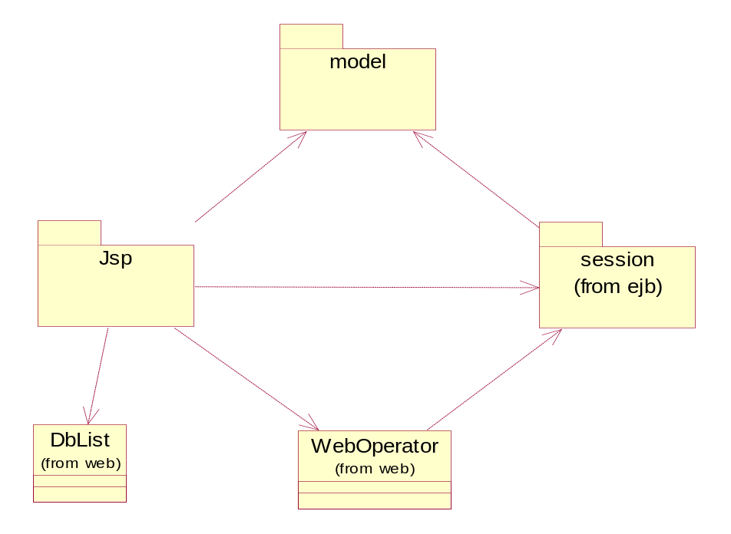
Figure 3-1 Relationships between Jsp and Session.

Jsp pages call business service though session bean’s remote interface. WebOperator is used to find the exact remote interface from EJB Container and applys to Jsp pages. Jsp pages package information into models and send them to session beans and retrieve information encapsulated into models from session beans. When user call first jsp page, DbList (do not have information, is it an java bean? Is there any design issue here?) load master data from database and keep them util (until?)shutdown web server. It serves for drop down list, therefor (therefore?), when jsp need create a drop down list, it can get data from memory. When user create, update or delete a mater data, DbList can be refreshed automoticly. (automatically)
There are five session beans in the system, MasterManagerBean, CompanyManagerBean, MatchManagerBean, BillingManagerBean and SecurityManagerBan. WebOperator can get service from them. The relation ship is shown in the Figure 3-2.
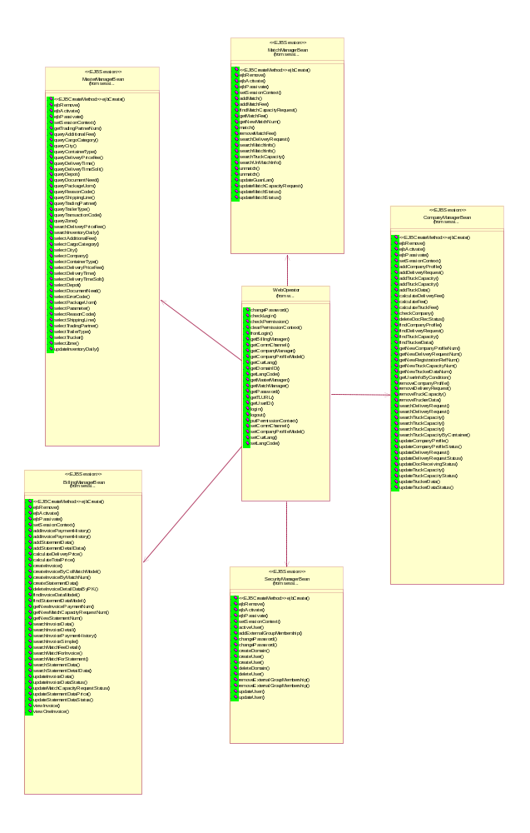
Figure 3-2 Relationships between WebOperator and Session Benas. (The diagram only shows the dependencies, will it contain further information?)

MasteManagerBean encapsulated query from master table such as city_data, container_type. DbList (not shown on the diagram above?) call these methods to retrieve master data from database.
CompanyManagerBean encapsulated all operations related to delivery request (what is the all operations mean?), truck capacity, company and trucker such as add, update a delivery request or search a shipper company by user input criteria. (Should be in more details!) Some important methods in CompanyManagerBean are listed in Data Dictionary in 3.2.2. (Some of it! It means 3.2.2 does not contain complete information!)
MatchManagerBean encapsulated all operators related to match capacity request (what is the all operations mean?), such as match a delivery request and a truck capacity, and update a match request capacity. Some important methods in MatchManager are listed in Data Dictionary in 3.2.2. (Some of it! That means 3.2.2 does not contain complete information)

BillingManagerBean encapsulated all operators related to billing, such as create an invoice, pint an invoice, create a statement, and create a payment. Some important methods in BillingManager are listed in Data Dictionary in 3.2.2. (Some of it! It means 3.2.2 does not contain complete information)

SecurityManagerBean encapsulated all operators related to security. All about security are detailedly described in 3.3. (Some of it! It means 3.2.2 does not contain complete information)

There are two type of database access method in session beans. If user needs a recordset such as the result of query, session beans run query through JDBC directly. If user needs update one record such as update a truck capacity record , session beans update the data throgh (through?) entity beans. The relations between session beans and entity beans are shown in Fig3-3.

It is also give us an ambiguous information of the EJBs, no details information discussed.
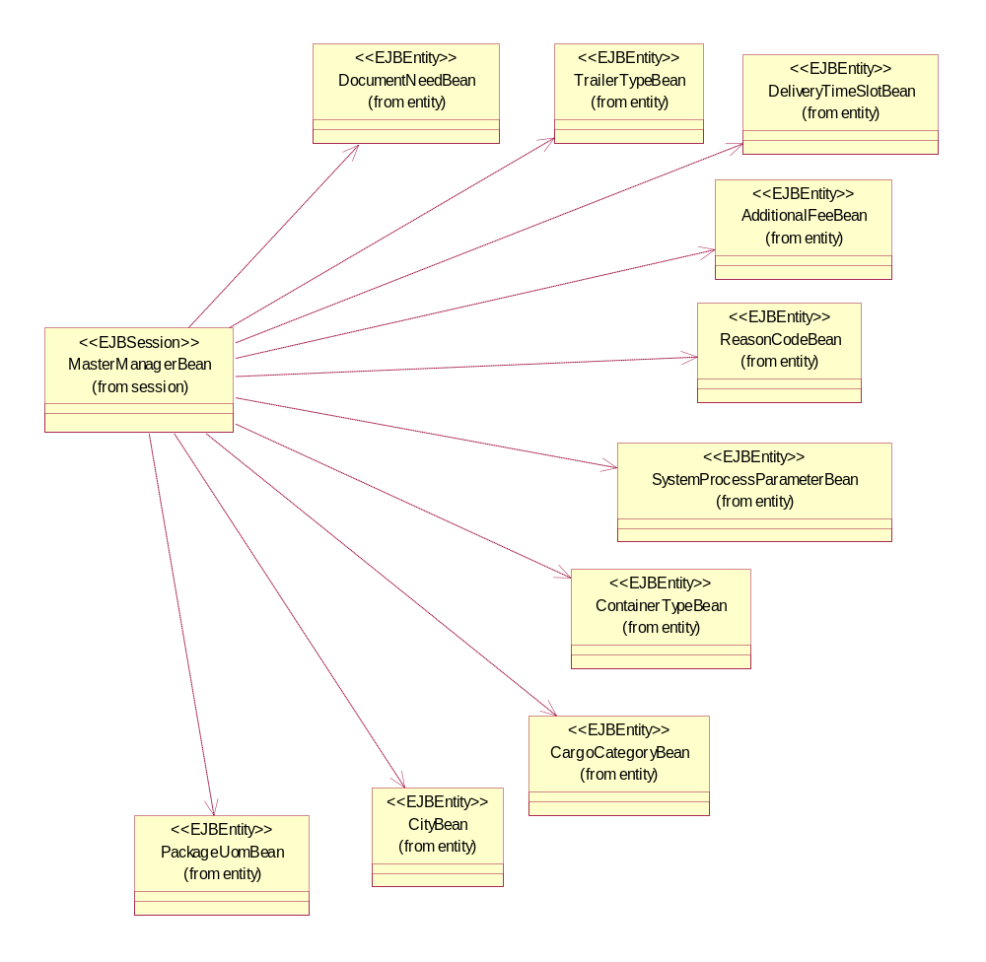
Figure 3-3 a. Relationships between MasterManager and Entity Beans.

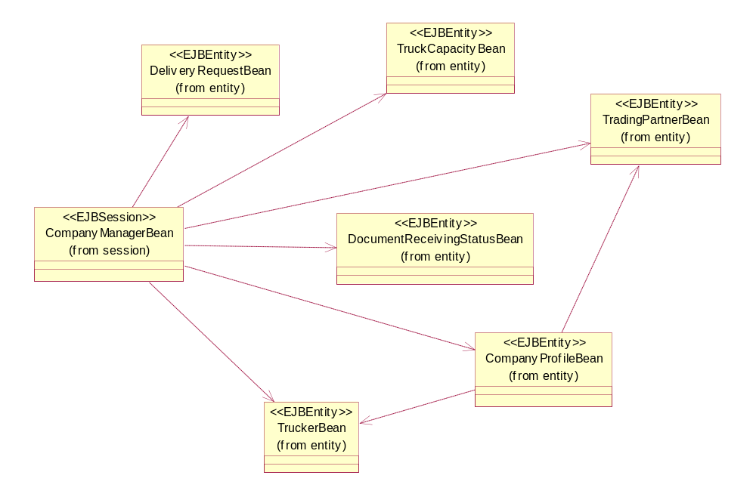
Figure 3-3 b. Relationships between CompanyManagerBean and Entity Beans.

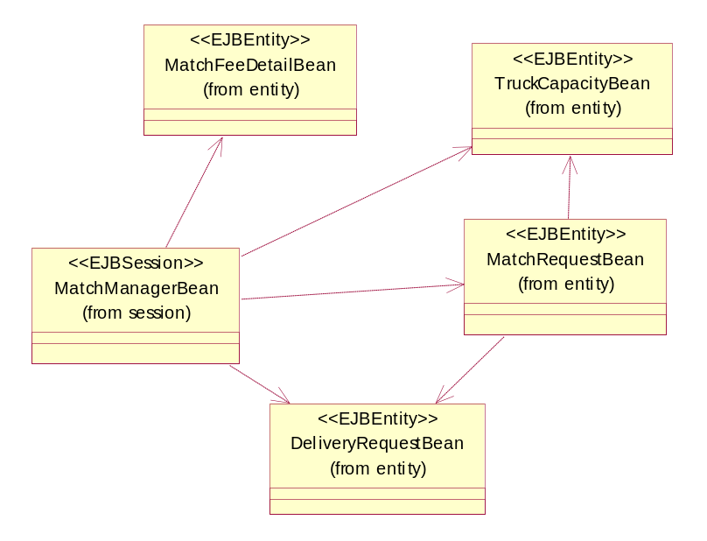
Figure 3-3 c. Relatationships between MatchManagerBean and Entity Benas.

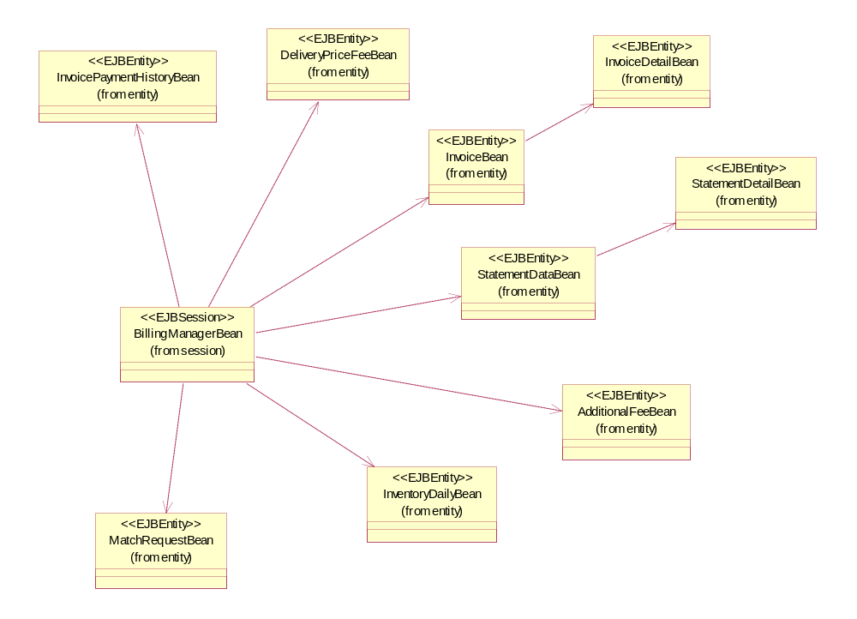
Figure 3-3 d. Relationships between BillingManagerBean and Entity Beans.
(The diagram only shows the Dependencies, it does not provide further information on how they interact!)

Package

To be honest, it is meaningless that only list names of the component and method without any description and explanation.

3.2.2.1 com.cbtb.ejb.session
  - class com.cbtb.ejb.session.BillingManagerBean (implements javax.ejb.SessionBean)
  - class com.cbtb.ejb.session.CompanyManagerBean (implements javax.ejb.SessionBean)
  - class com.cbtb.ejb.session.MasterManagerBean (implements javax.ejb.SessionBean)
  - class com.cbtb.ejb.session.MatchManagerBean (implements javax.ejb.SessionBean)
  - class com.cbtb.ejb.session.SecurityManagerBean (implements javax.ejb.SessionBean)
  - interface javax.ejb.EJBHome
    - interface com.cbtb.ejb.session.BillingManagerHome
    - interface com.cbtb.ejb.session.CompanyManagerHome
    - interface com.cbtb.ejb.session.MasterManagerHome
    - interface com.cbtb.ejb.session.MatchManagerHome
    - interface com.cbtb.ejb.session.SecurityManagerHome
  - interface javax.ejb.EJBObject
    - interface com.cbtb.ejb.session.BillingManager
    - interface com.cbtb.ejb.session.CompanyManager(also extends java.io.Serializable)
    - interface com.cbtb.ejb.session.MasterManager
    - interface com.cbtb.ejb.session.MatchManager
    - interface com.cbtb.ejb.session.SecurityManager

3.2.2.2 com.cbtb.ejb.entity
  - class com.cbtb.ejb.entity.AdditionalFeeBean (implements javax.ejb.EntityBean)
    - class com.cbtb.ejb.entity.AdditionalFeeBeanBMP
  - class com.cbtb.ejb.entity.AdditionalFeeValue (implements java.io.Serializable)
  - class com.cbtb.ejb.entity.CargoCategoryBean (implements javax.ejb.EntityBean)
    - class com.cbtb.ejb.entity.CargoCategoryBeanBMP
  - class com.cbtb.ejb.entity.CargoCategoryValue (implements java.io.Serializable)
  - class com.cbtb.ejb.entity.CityDataBean (implements javax.ejb.EntityBean)
    - class com.cbtb.ejb.entity.CityDataBeanBMP
  - class com.cbtb.ejb.entity.CityDataValue (implements java.io.Serializable)
  - class com.cbtb.ejb.entity.CompanyProfileBean (implements javax.ejb.EntityBean)
    - class com.cbtb.ejb.entity.CompanyProfileBeanBMP
  - class com.cbtb.ejb.entity.ContainerTypeBean (implements javax.ejb.EntityBean)
    - class com.cbtb.ejb.entity.ContainerTypeBeanBMP
  - class com.cbtb.ejb.entity.ContainerTypePK (implements java.io.Serializable)
  - class com.cbtb.ejb.entity.ContainerTypeValue (implements java.io.Serializable)
  - class com.cbtb.ejb.entity.DeliveryPriceFeeBean (implements javax.ejb.EntityBean)
    - class com.cbtb.ejb.entity.DeliveryPriceFeeBeanBMP
  - class com.cbtb.ejb.entity.DeliveryPriceFeePK (implements java.io.Serializable)
  - class com.cbtb.ejb.entity.DeliveryPriceFeeValue (implements java.io.Serializable)
  - class com.cbtb.ejb.entity.DeliveryRequestBean (implements javax.ejb.EntityBean)
    - class com.cbtb.ejb.entity.DeliveryRequestBeanBMP
  - class com.cbtb.ejb.entity.DeliveryTimeBean (implements javax.ejb.EntityBean)
    - class com.cbtb.ejb.entity.DeliveryTimeBeanBMP
  - class com.cbtb.ejb.entity.DeliveryTimeSlotBean (implements javax.ejb.EntityBean)
    - class com.cbtb.ejb.entity.DeliveryTimeSlotBeanBMP
  - class com.cbtb.ejb.entity.DeliveryTimeSlotValue (implements java.io.Serializable)
  - class com.cbtb.ejb.entity.DeliveryTimeValue (implements java.io.Serializable)
  - class com.cbtb.ejb.entity.DepotBean (implements javax.ejb.EntityBean)
    - class com.cbtb.ejb.entity.DepotBeanBMP
  - class com.cbtb.ejb.entity.DepotValue (implements java.io.Serializable)
  - class com.cbtb.ejb.entity.DocumentNeedBean (implements javax.ejb.EntityBean)
    - class com.cbtb.ejb.entity.DocumentNeedBeanBMP
  - class com.cbtb.ejb.entity.DocumentNeedValue (implements java.io.Serializable)
  - class com.cbtb.ejb.entity.DocumentReceivingStatusBean (implements javax.ejb.EntityBean)
    - class com.cbtb.ejb.entity.DocumentReceivingStatusBeanBMP
  - class com.cbtb.ejb.entity.DocumentReceivingStatusPK (implements java.io.Serializable)
  - class com.cbtb.ejb.entity.InventoryDailyBean (implements javax.ejb.EntityBean)
    - class com.cbtb.ejb.entity.InventoryDailyBeanBMP
  - class com.cbtb.ejb.entity.InventoryDailyPK (implements java.io.Serializable)
  - class com.cbtb.ejb.entity.InvoiceDataBean (implements javax.ejb.EntityBean)
    - class com.cbtb.ejb.entity.InvoiceDataBeanBMP
  - class com.cbtb.ejb.entity.InvoiceDetailDataBean (implements javax.ejb.EntityBean)
    - class com.cbtb.ejb.entity.InvoiceDetailDataBeanBMP
  - class com.cbtb.ejb.entity.InvoiceDetailDataPK (implements java.io.Serializable)
  - class com.cbtb.ejb.entity.InvoicePaymentHistoryBean (implements javax.ejb.EntityBean)
    - class com.cbtb.ejb.entity.InvoicePaymentHistoryBeanBMP
  - class com.cbtb.ejb.entity.InvoicePaymentHistoryPK (implements java.io.Serializable)
  - class com.cbtb.ejb.entity.MatchCapacityRequestBean (implements javax.ejb.EntityBean)
    - class com.cbtb.ejb.entity.MatchCapacityRequestBeanBMP
  - class com.cbtb.ejb.entity.MatchFeeDetailBean (implements javax.ejb.EntityBean)
    - class com.cbtb.ejb.entity.MatchFeeDetailBeanBMP
  - class com.cbtb.ejb.entity.MatchFeeDetailPK (implements java.io.Serializable)
  - class com.cbtb.ejb.entity.PackageUomBean (implements javax.ejb.EntityBean)
    - class com.cbtb.ejb.entity.PackageUomBeanBMP
  - class com.cbtb.ejb.entity.PackageUomValue (implements java.io.Serializable)
  - class com.cbtb.ejb.entity.ReasonCodeBean (implements javax.ejb.EntityBean)
    - class com.cbtb.ejb.entity.ReasonCodeBeanBMP
  - class com.cbtb.ejb.entity.ReasonCodeValue (implements java.io.Serializable)
  - class com.cbtb.ejb.entity.ShippingLineBean (implements javax.ejb.EntityBean)
    - class com.cbtb.ejb.entity.ShippingLineBeanBMP
  - class com.cbtb.ejb.entity.ShippingLineValue (implements java.io.Serializable)
  - class com.cbtb.ejb.entity.StatementDataBean (implements javax.ejb.EntityBean)
    - class com.cbtb.ejb.entity.StatementDataBeanBMP
  - class com.cbtb.ejb.entity.StatementDetailDataBean (implements javax.ejb.EntityBean)
    - class com.cbtb.ejb.entity.StatementDetailDataBeanBMP
  - class com.cbtb.ejb.entity.StatementDetailDataPK (implements java.io.Serializable)
  - class com.cbtb.ejb.entity.SystemProcessParameterBean (implements javax.ejb.EntityBean)
    - class com.cbtb.ejb.entity.SystemProcessParameterBeanBMP
  - class com.cbtb.ejb.entity.SystemProcessParameterValue (implements java.io.Serializable)
  - class com.cbtb.ejb.entity.TradingPartnerBean (implements javax.ejb.EntityBean)
    - class com.cbtb.ejb.entity.TradingPartnerBeanBMP
  - class com.cbtb.ejb.entity.TradingPartnerValue (implements java.io.Serializable)
  - class com.cbtb.ejb.entity.TrailerTypeBean (implements javax.ejb.EntityBean)
    - class com.cbtb.ejb.entity.TrailerTypeBeanBMP
  - class com.cbtb.ejb.entity.TrailerTypeValue (implements java.io.Serializable)
  - class com.cbtb.ejb.entity.TransactionCodeBean (implements javax.ejb.EntityBean)
    - class com.cbtb.ejb.entity.TransactionCodeBeanBMP
  - class com.cbtb.ejb.entity.TransactionCodeValue (implements java.io.Serializable)
  - class com.cbtb.ejb.entity.TransactionLogBean (implements javax.ejb.EntityBean)
    - class com.cbtb.ejb.entity.TransactionLogBeanBMP
  - class com.cbtb.ejb.entity.TransactionLogPK (implements java.io.Serializable)
  - class com.cbtb.ejb.entity.TruckCapacityBean (implements javax.ejb.EntityBean)
    - class com.cbtb.ejb.entity.TruckCapacityBeanBMP
  - class com.cbtb.ejb.entity.TruckerDataBean (implements javax.ejb.EntityBean)
    - class com.cbtb.ejb.entity.TruckerDataBeanBMP
  - class com.cbtb.ejb.entity.ZoneBean (implements javax.ejb.EntityBean)
    - class com.cbtb.ejb.entity.ZoneBeanBMP
  - class com.cbtb.ejb.entity.ZoneValue (implements java.io.Serializable)
  - interface javax.ejb.EJBHome
    - interface com.cbtb.ejb.entity.AdditionalFeeHome
    - interface com.cbtb.ejb.entity.CargoCategoryHome
    - interface com.cbtb.ejb.entity.CityDataHome
    - interface com.cbtb.ejb.entity.CompanyProfileHome
    - interface com.cbtb.ejb.entity.ContainerTypeHome
    - interface com.cbtb.ejb.entity.DeliveryPriceFeeHome
    - interface com.cbtb.ejb.entity.DeliveryRequestHome
    - interface com.cbtb.ejb.entity.DeliveryTimeHome
    - interface com.cbtb.ejb.entity.DeliveryTimeSlotHome
    - interface com.cbtb.ejb.entity.DepotHome
    - interface com.cbtb.ejb.entity.DocumentNeedHome
    - interface com.cbtb.ejb.entity.DocumentReceivingStatusHome
    - interface com.cbtb.ejb.entity.InventoryDailyHome
    - interface com.cbtb.ejb.entity.InvoiceDataHome
    - interface com.cbtb.ejb.entity.InvoiceDetailDataHome
    - interface com.cbtb.ejb.entity.InvoicePaymentHistoryHome
    - interface com.cbtb.ejb.entity.MatchCapacityRequestHome
    - interface com.cbtb.ejb.entity.MatchFeeDetailHome
    - interface com.cbtb.ejb.entity.PackageUomHome
    - interface com.cbtb.ejb.entity.ReasonCodeHome
    - interface com.cbtb.ejb.entity.ShippingLineHome
    - interface com.cbtb.ejb.entity.StatementDataHome
    - interface com.cbtb.ejb.entity.StatementDetailDataHome
    - interface com.cbtb.ejb.entity.SystemProcessParameterHome
    - interface com.cbtb.ejb.entity.TradingPartnerHome
    - interface com.cbtb.ejb.entity.TrailerTypeHome
    - interface com.cbtb.ejb.entity.TransactionCodeHome
    - interface com.cbtb.ejb.entity.TransactionLogHome
    - interface com.cbtb.ejb.entity.TruckCapacityHome
    - interface com.cbtb.ejb.entity.TruckerDataHome
    - interface com.cbtb.ejb.entity.ZoneHome
  - interface javax.ejb.EJBObject
    - interface com.cbtb.ejb.entity.AdditionalFee
    - interface com.cbtb.ejb.entity.CargoCategory
    - interface com.cbtb.ejb.entity.CityData
    - interface com.cbtb.ejb.entity.CompanyProfile
    - interface com.cbtb.ejb.entity.ContainerType
    - interface com.cbtb.ejb.entity.DeliveryPriceFee
    - interface com.cbtb.ejb.entity.DeliveryRequest
    - interface com.cbtb.ejb.entity.DeliveryTime
    - interface com.cbtb.ejb.entity.DeliveryTimeSlot
    - interface com.cbtb.ejb.entity.Depot
    - interface com.cbtb.ejb.entity.DocumentNeed
    - interface com.cbtb.ejb.entity.DocumentReceivingStatus
    - interface com.cbtb.ejb.entity.InventoryDaily
    - interface com.cbtb.ejb.entity.InvoiceData
    - interface com.cbtb.ejb.entity.InvoiceDetailData
    - interface com.cbtb.ejb.entity.InvoicePaymentHistory
    - interface com.cbtb.ejb.entity.MatchCapacityRequest
    - interface com.cbtb.ejb.entity.MatchFeeDetail
    - interface com.cbtb.ejb.entity.PackageUom
    - interface com.cbtb.ejb.entity.ReasonCode
    - interface com.cbtb.ejb.entity.ShippingLine
    - interface com.cbtb.ejb.entity.StatementData
    - interface com.cbtb.ejb.entity.StatementDetailData
    - interface com.cbtb.ejb.entity.SystemProcessParameter
    - interface com.cbtb.ejb.entity.TradingPartner
    - interface com.cbtb.ejb.entity.TrailerType
    - interface com.cbtb.ejb.entity.TransactionCode
    - interface com.cbtb.ejb.entity.TransactionLog
    - interface com.cbtb.ejb.entity.TruckCapacity
    - interface com.cbtb.ejb.entity.TruckerData
    - interface com.cbtb.ejb.entity.Zone

3.2.2.3 com.cbtb. exception
          - class com.cbtb.exception.CbtbException (implements java.io. Serializable)

3.2.2.4 com.cbtb. model
  - class com.cbtb.model.CityDataModel (implements java.io.Serializable)
  - class com.cbtb.model.CityZoneModel (implements java.io.Serializable)
  - class com.cbtb.model.CompanyProfileModel (implements java.io.Serializable)
  - class com.cbtb.model.ContainerTypeTrailerModel (implements java.io.Serializable)
  - class com.cbtb.model.DeliveryPriceFeeModel (implements java.io.Serializable)
  - class com.cbtb.model.DeliveryRequestModel (implements java.io.Serializable)
  - class com.cbtb.model.DeliveryTimeModel (implements java.io.Serializable)
  - class com.cbtb.model.DepotDataModel (implements java.io.Serializable)
  - class com.cbtb.model.DocRecStatusModel (implements java.io.Serializable)
  - class com.cbtb.model.ErrorCodeModel (implements java.io.Serializable)
  - class com.cbtb.model.InventoryDailyModel (implements java.io.Serializable)
  - class com.cbtb.model.InvoiceDataModel (implements java.io.Serializable)
  - class com.cbtb.model.InvoiceDetailDataModel (implements java.io.Serializable)
  - class com.cbtb.model.InvoicePaymentHistoryModel (implements java.io.Serializable)
  - class com.cbtb.model.MatchFeeDetailModel (implements java.io.Serializable)
  - class com.cbtb.model.MatchModel (implements java.io.Serializable)
  - class com.cbtb.model.StatementDataModel (implements java.io.Serializable)
  - class com.cbtb.model.StatementDetailDataModel (implements java.io.Serializable)
  - class com.cbtb.model.TransactionCodeModel (implements java.io.Serializable)
  - class com.cbtb.model.TransFormat
  - class com.cbtb.model.TruckCapacityModel (implements java.io.Serializable)
  - class com.cbtb.model.TruckerDataModel (implements java.io.Serializable)
  - class com.cbtb.model.TruckMatchModel (implements java.io.Serializable)
  - class com.cbtb.model.ZoneDataModel (implements java.io.Serializable)

3.2.2.5 com.cbtb.web
  - class com.cbtb.web. CbtbErrorContext
  - class com.cbtb.web. DbList.java
  - class com.cbtb.web.WebOperator
  - class com.cbtb.web.MatchStatus

3.2.2.6 com.cbtb.util
  - class com.cbtb.util.CbtbConstant
  - class com.cbtb.util.Debug
  - class com.cbtb.util.EjbUtil
  - class com.cbtb.util.NewPagination
  - class com.cbtb.util.NumberConvertText
  - class com.cbtb.util.Pagination
  - class com.cbtb.util.UtilTool

3.2.2.7 com.cbtb. javabean
  - class com.cbtb.javabean.AddFeeJB (implements java.io.Serializable)
  - class com.cbtb.javabean.CargoCategoryJB
  - class com.cbtb.javabean.CityJB (implements java.io.Serializable)
  - class com.cbtb.javabean.ContainerTypeJB (implements java.io.Serializable)
  - class com.cbtb.javabean.DeliveryPriceFeeJB (implements java.io.Serializable)
  - class com.cbtb.javabean.DeliveryTimeJB
  - class com.cbtb.javabean.DeliveryTimeSlotJB
  - class com.cbtb.javabean.DepotJB
  - class com.cbtb.javabean.DocumentNeedJB (implements java.io.Serializable)
  - class com.cbtb.javabean.PackageUomJB (implements java.io.Serializable)
  - class com.cbtb.javabean.ReasonCodeJB (implements java.io.Serializable)
  - class com.cbtb.javabean.ShippingLineJB
  - class com.cbtb.javabean.SystemParameterJB
  - class com.cbtb.javabean.TradingPartnerJB
  - class com.cbtb.javabean.TrailerTypeJB
  - class com.cbtb.javabean.TransactionCodeJB
  - class com.cbtb.javabean.ZoneJB

Method Description
com.cbtb.ejb.session

3.2.3.1 BillingManager
public Collection searchMatchForStatement(String companyId,String matchNum,
String beginDate,String endDate,String status,String orderByName)
throws RemoteException;
public String getNewMatchCapacityRequestNum() throws RemoteException;
public boolean updateMatchCapacityRequestStatus(String matchNum,String status)
throws RemoteException;
public StatementData addStatementData(String truckCompanyNo, String statementNo,
String statementAddr1, String statementAddr2, String statementAddr3,
String statementAddr4, String contactPerson, String contactChinesePerson,
BigDecimal totalPrice, Timestamp fromDate, Timestamp toDate,
String statementStatus, String payStatus, String totalFullText,
Timestamp creationDate) throws RemoteException;
public StatementDetailData addStatementDetailData(String statementNo,
String matchNumber, String truckCapacityNum, String containerTypeId,
String originCity, String destinationCity, Timestamp deliveryDate,
BigDecimal deliveryPrice) throws RemoteException;
public boolean addStatementData(StatementDataModel sdm)
throws RemoteException;
public boolean addStatementDetailData(StatementDetailDataModel sddm)
throws RemoteException;
public Collection createStatementData(String companyId,String matchNum,String beginDate,String endDate)
throws RemoteException;
public BigDecimal calculateDeliveryPrice(String matchNumber) throws RemoteException;
public BigDecimal calculateTotalPrice(String statementNo) throws RemoteException;
public StatementDataModel findStatementDataModel(String statementNo) throws RemoteException;
public String getNewStatementNum() throws RemoteException;
public Collection searchStatementDetailData(String statementNo) throws RemoteException;
public Collection searchStatementData(String companyId,String statementNo,String beginDate,String endDate,String status) throws RemoteException;
public boolean updateStatementDataPrice(java.lang.String statementNo, java.math.BigDecimal totalPrice)
throws RemoteException;
public Collection searchMatchFeeDetail(String matchNumber) throws RemoteException;
public Collection createInvoice(String companyId,String matchNum,
String beginDate,String endDate) throws RemoteException;
public Collection createInvoiceByColMatchModel(Collection colMatchModel,String fromDate,String toDate)
throws RemoteException;
public Collection createInvoiceByMatchNum(Collection colMatchNum,String fromDate,String toDate)
throws RemoteException;

public boolean deleteInvoiceDetailDataByPK(InvoiceDetailDataPK pk) throws RemoteException;
public Collection searchInvoiceSimple(String shipperNo,String invoiceNo,String beginInvoiceCreateDate,String endInvoiceCreateDate,Vector invoiceStatus) throws RemoteException,CbtbException;
public Collection searchInvoiceDetail(String shipperNo,String invoiceNo,String beginInvoiceCreateDate,
String endInvoiceCreateDate,Vector invoiceStatus) throws RemoteException,CbtbException;
public Collection searchMatchForInvoice(String companyId,Vector matchNum,String beginDate,String endDate,
Vector matchStatus,String orderByName) throws RemoteException;
public boolean updateInvoiceDataStatus(String invoiceNo,String status) throws RemoteException,CbtbException;
public boolean updateInvoiceData(InvoiceDataModel idm) throws RemoteException;
public InvoiceDataModel viewOneInvoice(String invoiceNo) throws RemoteException,CbtbException;
public Collection viewInvoice(Vector vctInvoiceNo) throws RemoteException,CbtbException;
public java.lang.String getNewInvoicePaymentNum() throws SQLException, RemoteException;
public java.util.Collection searchInvoicePaymentHistory(java.lang.String invoiceNo) throws RemoteException;
public java.util.Collection searchInvoiceData(java.lang.String shipperNo, java.lang.String invoiceNo,
java.lang.String creationDate, java.lang.String invoiceStatus, java.lang.String orderByName)
throws RemoteException;
public boolean addInvoicePaymentHistory(java.lang.String invoiceNo, java.sql.Timestamp paymentDate,
java.lang.String paidBy, java.lang.String ref, java.math.BigDecimal payAmount) throws CbtbException,
Exception, RemoteException;
public boolean addInvoicePaymentHistory(java.lang.String invoiceNo, java.lang.String paymentDate,
java.lang.String paidBy, java.lang.String ref, java.lang.String payAmount) throws CbtbException,
Exception, RemoteException;
public boolean updateStatementDataStatus(java.lang.String statementNo, java.lang.String status) throws CbtbException, RemoteException;
public com.cbtb.model.InvoiceDataModel findInvoiceDataModel(java.lang.String invoiceNo) throws RemoteException;

3.2.3.2 CompanyManager
public java.lang.String getNewDeliveryRequestNum() throws RemoteException;
public java.lang.String getName() throws RemoteException;
public com.cbtb.model.DeliveryRequestModel findDeliveryRequest(java.lang.String deliveryRequestNum)
throws RemoteException;
public boolean updateDeliveryRequestStatus(java.lang.String deliveryRequestNum, java.lang.String status)
throws RemoteException;
public String getNewTruckCapacityNum() throws RemoteException;
public java.util.Collection searchTruckCapacity(java.lang.String truckCapacityNum, java.lang.String originZoneId, java.lang.String companyId, java.lang.String originCityId, java.lang.String destinationCityId, java.lang.String deliveryDate, java.lang.String deliveryTimeId, java.lang.String deliveryTimeSlot, java.lang.String trailerId, java.lang.String matchNumber, java.lang.String destinationZoneId, java.lang.String truckCapacityStatus, java.lang.String orderByName) throws RemoteException;
public com.cbtb.model.TruckCapacityModel findTruckCapacity(java.lang.String truckCapacityNum)
throws RemoteException;
public boolean removeTruckCapacity(java.lang.String truckCapacityNum) throws RemoteException;
public boolean updateTruckCapacityStatus(java.lang.String truckCapacityNum, java.lang.String status)
throws RemoteException;
public boolean checkCompany(java.lang.String companyId) throws RemoteException;
public java.util.Collection searchDeliveryRequest(java.lang.String companyId, java.lang.String matchNumber, java.lang.String originZoneId, java.lang.String originCityId, java.lang.String destinationZoneId, java.lang.String destinationCityId, java.lang.String requestStatus, java.lang.String containerTypeId, java.lang.String deliveryDate, java.lang.String deliveryRequestNum, java.lang.String deliveryTime, java.lang.String timeSlotId, java.lang.String shippingOrderNo, java.lang.String orderByName) throws RemoteException;

public boolean removeCompanyProfile(String companyId) throws RemoteException;
public boolean addCompanyProfile(CompanyProfileModel cpm) throws CbtbException,RemoteException;
public String getNewRegistrationRefNum() throws RemoteException;
public String getNewCompanyProfileNum() throws RemoteException;
public CompanyProfileModel findCompanyProfile(String companyId) throws RemoteException;
public boolean updateCompanyProfileStatus(String companyId, String status) throws RemoteException;
public boolean removeTruckerData(String truckerId) throws RemoteException;
public TruckerData addTruckerData(String companyId, String truckerId,
String truckerName, String truckerChineseName, String hkId,
String truckerAddr1, String truckerAddr2, String truckerAddr3,
String truckerAddr4, String hkTelephoneNo, String hkMobileNo,
String hkPagerNo, String inlandTelephoneNo, String inlandMobileNo,
String inlandPagerNo, String hkLicenseNo, String inlandLicenseNo,
String hkPlateNo, String inlandPlateNo, String truckModelNo,
String truckColor, String carryWeight, String remark, String truckStatus,
String reasonId, Timestamp creationDate) throws RemoteException;
public boolean addTruckerData(TruckerDataModel tdm) throws RemoteException;
public String getNewTruckerDataNum() throws RemoteException;
public TruckerDataModel findTruckerData(String truckerId) throws RemoteException;
public boolean updateTruckerDataStatus(String truckerId, String status) throws RemoteException;
public java.math.BigDecimal calculateDeliveryFee(java.lang.String containerTypeId, java.lang.String originCityId, java.lang.String destinationCityId) throws RemoteException;
public java.util.Collection searchDeliveryRequest(java.lang.String companyId) throws RemoteException;
public java.util.Collection searchTruckCapacity(java.lang.String companyId) throws RemoteException;
public java.math.BigDecimal calculateTruckFee(java.lang.String trailerId, java.lang.String originCityId, java.lang.String destinationCityId) throws RemoteException;
public java.math.BigDecimal calculateFee(java.lang.String containerTypeId, java.lang.String cityId, boolean isIB,
boolean isShipper) throws RemoteException;
public java.util.Collection searchTruckCapacity(java.lang.String truckerId, java.lang.String companyId)
throws RemoteException;
public java.util.Collection getUserInfoByCondition(java.lang.String companyId, java.lang.String companyName, java.lang.String contactPerson, java.lang.String telephoneNo, java.lang.String faxNo, java.lang.String HKMobileNo, java.lang.String truckerName, java.lang.String HKPlateNo, java.lang.String selectType, java.lang.String refNum, java.lang.String HKLicenseNo,java.lang.String truckerId, java.lang.String orderBy) throws RemoteException;
public boolean addDeliveryRequest(com.cbtb.model.DeliveryRequestModel drm) throws CbtbException, RemoteException;
public boolean updateDeliveryRequest(com.cbtb.model.DeliveryRequestModel drm)
throws CbtbException, RemoteException;
public boolean updateTruckCapacity(com.cbtb.model.TruckCapacityModel tcm) throws CbtbException, RemoteException;
public boolean addTruckCapacity(java.util.Collection truckCapacitys) throws CbtbException, RemoteException;
public boolean addTruckCapacity(com.cbtb.model.TruckCapacityModel tcm) throws CbtbException, RemoteException;
public boolean updateCompanyProfile(com.cbtb.model.CompanyProfileModel cpm)
throws CbtbException, RemoteException;
public boolean updateTruckerData(com.cbtb.model.TruckerDataModel tdm) throws CbtbException, RemoteException;
public boolean removeDeliveryRequest(java.lang.String deliveryRequestNum) throws CbtbException, RemoteException;
public boolean deleteDocRecStatus(com.cbtb.model.DocRecStatusModel drsm) throws RemoteException;
public boolean updateDocReceivingStatus(com.cbtb.model.DocRecStatusModel drsm) throws RemoteException;
public java.util.Collection searchTruckCapacityByContainer(java.lang.String truckCapacityNum, java.lang.String originZoneId, java.lang.String companyId, java.lang.String originCityId, java.lang.String destinationCityId, java.lang.String deliveryDate, java.lang.String deliveryTimeId, java.lang.String deliveryTimeSlot, java.lang.String containerTypeId, java.lang.String matchNumber, java.lang.String destinationZoneId, java.lang.String truckCapacityStatus, java.lang.String orderByName) throws RemoteException;

3.2.3.3 MasterManager
public ArrayList selectCity() throws java.rmi.RemoteException ,FinderException;
public Collection queryCity(String sqlString) throws java.rmi.RemoteException ,FinderException;
public ArrayList selectZone() throws java.rmi.RemoteException ,FinderException;
public Collection queryZone(String sqlString) throws java.rmi.RemoteException ,FinderException;
public ArrayList selectContainerType() throws java.rmi.RemoteException ,FinderException;
public ArrayList selectShippingLine() throws java.rmi.RemoteException ,FinderException;
public ArrayList selectTransactionCode() throws java.rmi.RemoteException ,FinderException;
public Collection queryContainerType(String sqlString) throws java.rmi.RemoteException ,FinderException;
public Collection queryShippingLine(String sqlString) throws java.rmi.RemoteException ,FinderException;
public Collection queryTransactionCode(String sqlString) throws java.rmi.RemoteException ,FinderException;
public ArrayList selectPackageUom() throws java.rmi.RemoteException ,FinderException;
public Collection queryPackageUom(String sqlString) throws java.rmi.RemoteException ,FinderException;
public ArrayList selectReasonCode() throws java.rmi.RemoteException ,FinderException;
public Collection queryReasonCode(String sqlString) throws java.rmi.RemoteException ,FinderException;
public ArrayList selectDocumentNeed() throws java.rmi.RemoteException ,FinderException;
public Collection queryDocumentNeed(String sqlString) throws java.rmi.RemoteException ,FinderException;
public ArrayList selectDeliveryTime() throws java.rmi.RemoteException ,FinderException;
public Collection queryDeliveryTime(String sqlString) throws java.rmi.RemoteException ,FinderException;
public ArrayList selectDeliveryTimeSolt() throws java.rmi.RemoteException ,FinderException;
public Collection queryDeliveryTimeSolt(String sqlString) throws java.rmi.RemoteException ,FinderException;
public ArrayList selectTrailerType() throws java.rmi.RemoteException ,FinderException;
public ArrayList selectCargoCategory() throws java.rmi.RemoteException ,FinderException;
public ArrayList selectDepot() throws java.rmi.RemoteException ,FinderException;
public Collection queryCargoCategory(String sqlString) throws java.rmi.RemoteException ,FinderException;
public Collection queryTrailerType(String sqlString) throws java.rmi.RemoteException ,FinderException;
public Collection queryDepot(String sqlString) throws java.rmi.RemoteException ,FinderException;
public Collection queryAdditionalFee (String sqlString)throws java.rmi.RemoteException ,FinderException;
public ArrayList selectAdditionalFee() throws java.rmi.RemoteException ,FinderException;
public ArrayList selectDeliveryPriceFee() throws java.rmi.RemoteException ,FinderException;
public Collection queryDeliveryPriceFee(String sqlString) throws java.rmi.RemoteException ,FinderException;
public ArrayList selectParameter() throws java.rmi.RemoteException ,FinderException;
public java.util.Collection queryTradingPartner(java.lang.String sqlString)
throws java.rmi.RemoteException, FinderException, RemoteException;
public java.util.ArrayList selectTradingPartner() throws java.rmi.RemoteException, FinderException, RemoteException;
public java.util.Collection selectCompany() throws java.rmi.RemoteException, FinderException, RemoteException;
public java.util.Collection selectTrucker() throws java.rmi.RemoteException, FinderException, RemoteException;
public java.util.Collection selectErrorCode() throws RemoteException;
public void throwExceptionTest() throws CbtbException, RemoteException;
public java.util.Collection searchInventoryDaily(java.lang.String depotId, java.lang.String shippingLineId, java.lang.String containerTypeId, java.lang.String captureDate) throws CbtbException, RemoteException;
public boolean updateInventoryDaily(java.util.Collection inventoryDailyList) throws CbtbException, RemoteException;
public java.util.Collection searchDeliveryPriceFee(java.lang.String containerTypeId,
java.lang.String cityId, java.lang.String zoneId) throws RemoteException;
public java.lang.String getTradingPartnerNum() throws RemoteException;

3.2.3.4 MatchManager
public com.cbtb.model.MatchModel match(java.lang.String deliveryRequestNum, java.lang.String truckCapacityNum) throws RemoteException, CbtbException;
public boolean removeMatchFee(java.util.Collection matchFeeList) throws CbtbException, RemoteException;
public boolean addMatchFee(com.cbtb.model.MatchFeeDetailModel mfdm) throws CbtbException, RemoteException;
public java.util.Collection getMatchFee(java.lang.String matchNumber) throws RemoteException;
public com.cbtb.model.MatchModel findMatchCapacityRequest(java.lang.String matchNumber) throws RemoteException;
public java.util.Collection searchTruckCapacity(java.lang.String truckCapacityNum, java.lang.String companyName, java.lang.String originCityId, java.lang.String destinationCityId, java.lang.String deliveryDate, java.lang.String deliveryTimeId, java.lang.String trailerId, java.lang.String orderByName) throws RemoteException;
public java.util.Collection searchMatchInfo(java.lang.String companyID, java.lang.String companyName, java.lang.String matchNumber, java.lang.String truckerName, java.lang.String deliveryDate, java.lang.String deliveryTimeID, java.lang.String originCityID, java.lang.String destinationCityID, java.lang.String matchStatus, java.lang.String orderByField) throws RemoteException;
public boolean updateMatchStatus(java.lang.String matchNum, java.lang.String status) throws RemoteException;
public java.util.Collection autoMatch() throws RemoteException;
public java.util.Collection searchDeliveryRequest(java.lang.String deliveryRequestNum, java.lang.String companyName, java.lang.String originCityId, java.lang.String destinationCityId, java.lang.String deliveryDate, java.lang.String deliveryTimeId, java.lang.String containerTypeId, java.lang.String orderByName) throws RemoteException;
public java.util.Collection searchUnMatchInfo(java.lang.String companyId, java.lang.String matchNumber, java.lang.String deliveryRequestNum, java.lang.String truckCapacityNum, java.lang.String deliveryDate, java.lang.String deliveryTimeId, java.lang.String originCityId, java.lang.String destinationCityId, java.lang.String trailerTypeId, java.lang.String containerTypeId, java.lang.String orderByName) throws RemoteException;
public boolean updateMatchStatus(java.lang.String matchNum, java.lang.String deliveryRequestNum, java.lang.String truckCapacityNum, java.lang.String status) throws CbtbException, RemoteException;
public boolean updateMatchCapacityRequest(com.cbtb.model.MatchModel mm) throws CbtbException, RemoteException;
public boolean updateGuanLan(java.util.Collection matchList) throws CbtbException, RemoteException;
public java.util.Collection searchMatchInfo(java.lang.String companyID, java.lang.String companyName, java.lang.String matchNumber, java.lang.String truckerName, java.lang.String deliveryDate, java.lang.String deliveryTimeID, java.lang.String hkPlateNo, java.lang.String orderByField) throws RemoteException;
public boolean unmatch(java.lang.String matchNum) throws CbtbException, RemoteException;
public boolean unmatch(java.lang.String[] matchNumber) throws CbtbException, RemoteException;
public com.cbtb.ejb.entity.MatchCapacityRequest addMatch(com.cbtb.model.MatchModel matchModel)
throws CbtbException, RemoteException;
public java.lang.String getNewMatchNum() throws CbtbException, RemoteException;

3.2.3.5 SecurityManager
public void createDomain(String domainID,String domainName,String domainDesc,String domainType)
throws CbtbException,RemoteException;
public void deleteDomain(String domainID) throws CbtbException,RemoteException;
public void createUser( String domainID,String userID,String encryptPassword,String description)
throws CbtbException,RemoteException;
public void createUser(String domainID,String domainType,String userID,String unEncryptPassword,String userType,
String description)throws CbtbException,RemoteException;
public void suspendUser(String domainID,String userID) throws CbtbException,RemoteException;
public void activeUser(String domainID,String userID) throws CbtbException,RemoteException;
public void changePassword(String domainID,String userID,String newEncriptPassword)
throws CbtbException,RemoteException;
public void changePassword(String domainID,String userID,String password,boolean isEncrypt)
throws CbtbException,RemoteException;
public void deleteUser(String domainID,String userID)throws CbtbException,RemoteException;
public void updateUser(net.line.fortress.apps.system.security.User user)throws CbtbException,RemoteException;
public void updateUser(String domainID,String userID,String suspend,String newEncriptPassword,String description)
throws CbtbException,RemoteException;
public Collection findUserByDomain(String domainID) throws CbtbException,RemoteException;
public void addExternalGroupMembership(String domainID,String userID,String userType)
throws CbtbException,RemoteException;
public void removeExternalGroupMembership(String principalDomainID,String principal,String userOrGroup,
String groupID )throws CbtbException,RemoteException;
public void removeExternalGroupMembership(String domainID,String userID,String userType)
throws CbtbException,RemoteException;

JSP Desciption
Separate system into front subsystem and backend subsystem
The whole session only lists the pages without any further information. That is to say it does not tell what and how about the JSPs in the system

3.2.4.1 Front Subsystem
Shipper Company Login
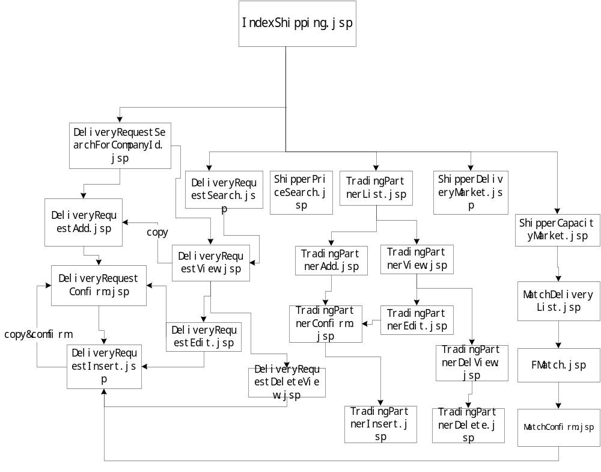

Trucking Company Login
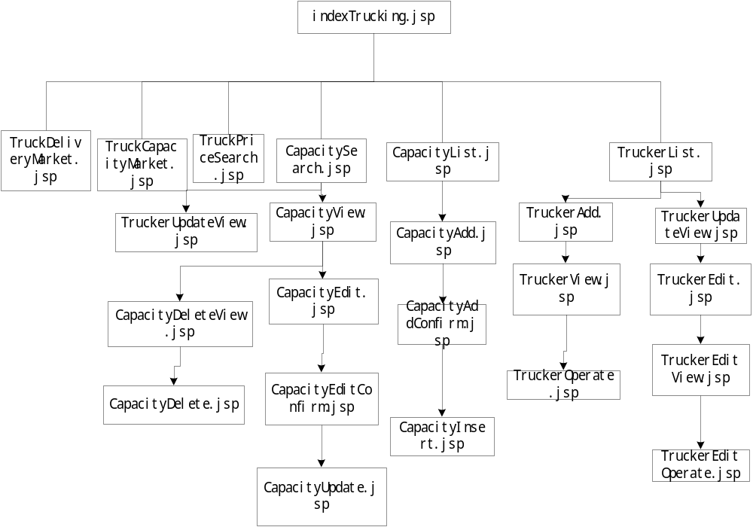

3.2.4.2 Backend Subsystem

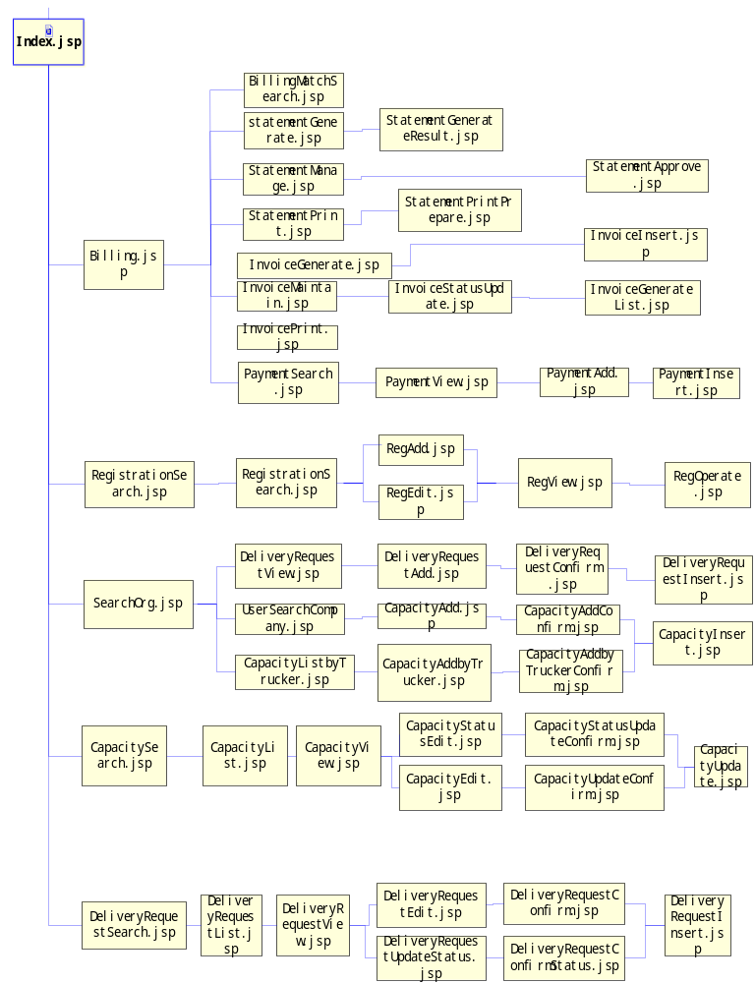

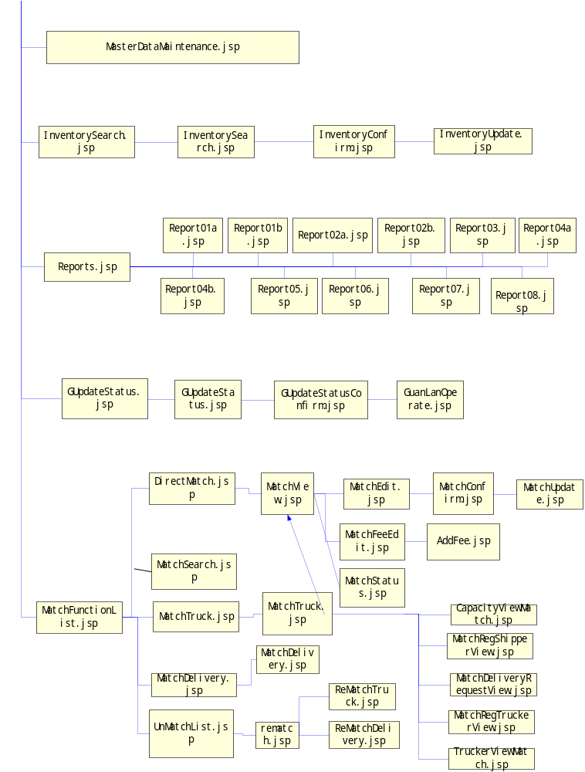

Dynamic Model
There are several complex and important business actions in the system, post deivery ( delivery? ) request, post truck capacity, match, generate invoice, generate statement and message query. (queue?) The following sections, 3.3.1 to 3.3.6, describe the detail of these actions. Each action is shown with sequence diagram.

Post Delivery Request
When user want to add a new delivery request, In the delivery request list view form, click the “new” button, link to create new delivery request form, input delivery request, when post the delivery request, in delivery request confirm form ,will list the effective delivery request, when click “confirm”, system will pack all delivery request into a deliveryRequestModel, and transfer session bean companyManager’s verifyDeliveryRequestAdd (deliveryRequestModel) method to verify delivery request data, if delivery request data right ,will transfer session bean companyManager’s addDeliveryRequest(deliveryRequestModel) method to add delivery request data to database; In method addDeliveryRequest, it will transfer entity bean deliveryrequestbean ejbCreate() method to add delivery request data to database authentically.
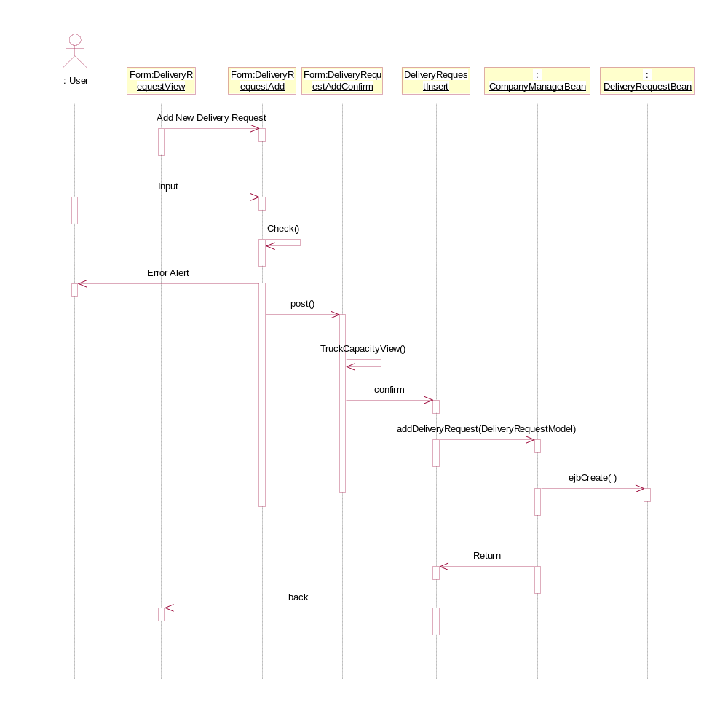
Figure 3-4 post truck capacity
(Should be in the new session) When user want to add a new truck capacity, In the capacity list view form, click the “new” button, link to create new capacity form, input base capacity info, and trucker info(not more than 5 truckers), when post these capacitys (capacities?), in capacity confirm form ,will list all effective capacity, when click “confirm”, system will pack all capacity into a truckCapacityModel, and transfer session bean companyManager’s verifyTruckCapacityAdd(truckCapacityModels) method to verify capacity data, if all data right ,will transfer session bean companyManager’s addTruckCapacity(truckCapacityModels) method to add capacity data to database; In method addTruckCapacity, it will transfer entity bean truckcapacitybean ejbCreate() method to add capacity data to database authentically.

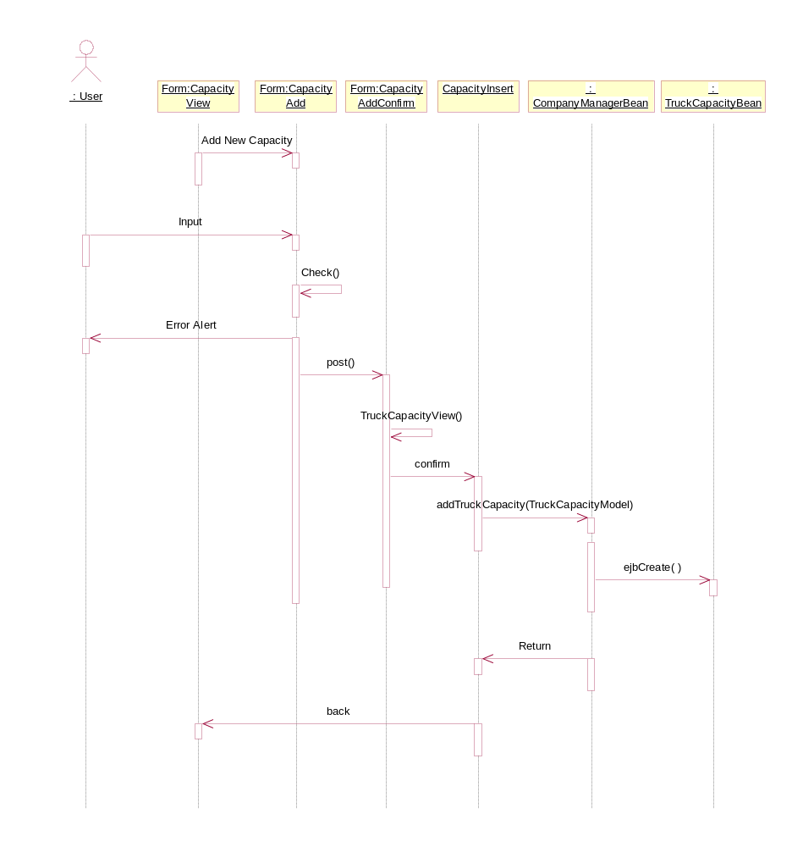
Figure 3-5 post delivery request

Match
When user wants to complete a match, he or she can choice match by delivery, match by truck capacity or match directly. There are three methods in the MatchManagerBeans served for this action, searchDeliveryRequest, searchTruckCapacity and match. The difference between match by delivery and match by truck capacity is call the three methods in the different sequence, and match directly aciton call match method directly. Match by delivery request is shown in Figure 3-6
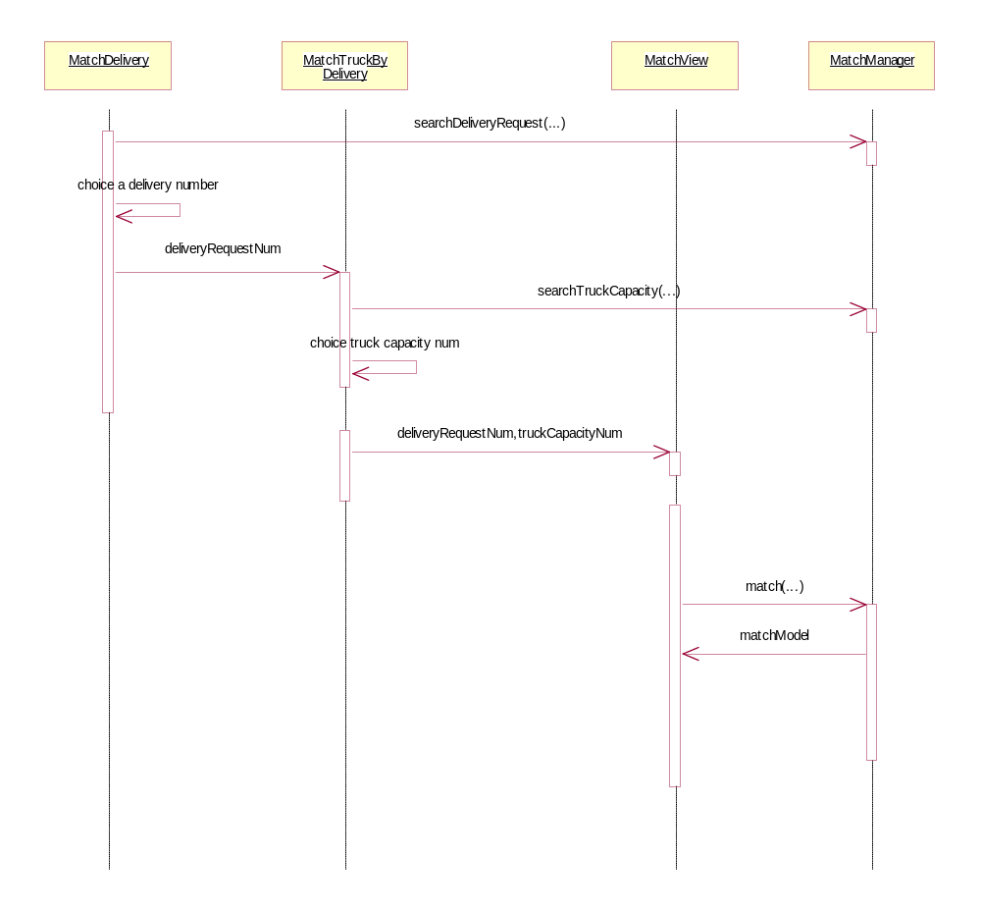
Figure 3-6 Matches by Delviery Request Driectly

No matter what action user choice, the system will call match method at last. Match method receives two parameters, deliveryCapacityNum and truckCapacityNum, and finds the corresponding delivery request and truck capacity by the number, then compare the match information such as origin city, destination city, time, timslot (time slot?) etc (which components and methods will handle these sort of thing?). If all conditions are satisfied, the method creates a new match record and returns the record to MatchView. (how about if not?) The following is the match condition:
a. Only posted delivery request and truck capacity can match
b. Origin City & Destination City and Delivery Date/Time must be exactly match. If truck capacity's origin or destination is 'Any', then it can be matched with any request's city.
c. Delivery_Date - CurrentDate <= System_Process_Parameter.Process_Lead_Time
d. There must be relationship between the truck capacity’s trailer and delivery request’s container in Container_Type table.
e. It will check related shipping line's container inventory for the delivery request date and the container type of the delivery request, if on the delivery date, the shipping line has enough contianer, the match successful, system will increase the reserved QTY for the related container inventory.

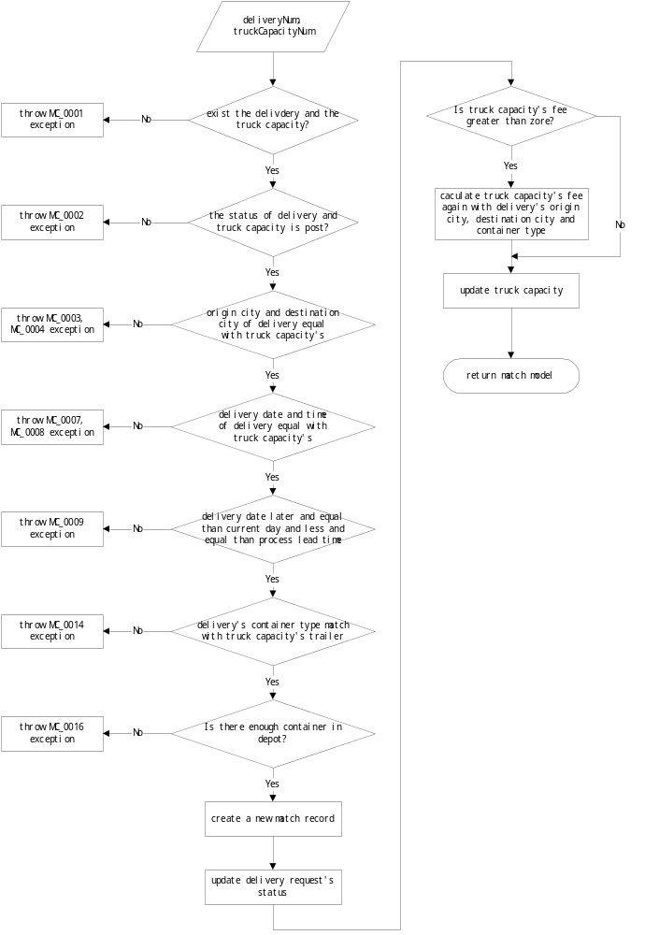 Figure 3-7 Match Flow
(Activity diagrams may be used, more details should be given, it should not be in same level with the functional design specification)

Generate Invoice
When user want to generate invoice, In the invoice generate form, input criteria (shipper id, Match Number), and click search, will list all interrelated match records, which have been approved or generated service report; then click generate, system will pack all match information into a colInvoiceDataModel, and transfer session bean BillingManager’s createInvoiceByColMatchModel method to generate several invoices base on different shipper company; In method createInvoiceByColMatchModel, it will transfer entity bean invoiceDataBean ejbCreate() method to add invoice data to database, and transfer entity bean invoiceDataDetailBean ejbCreate() method to add invoice detail data to database .
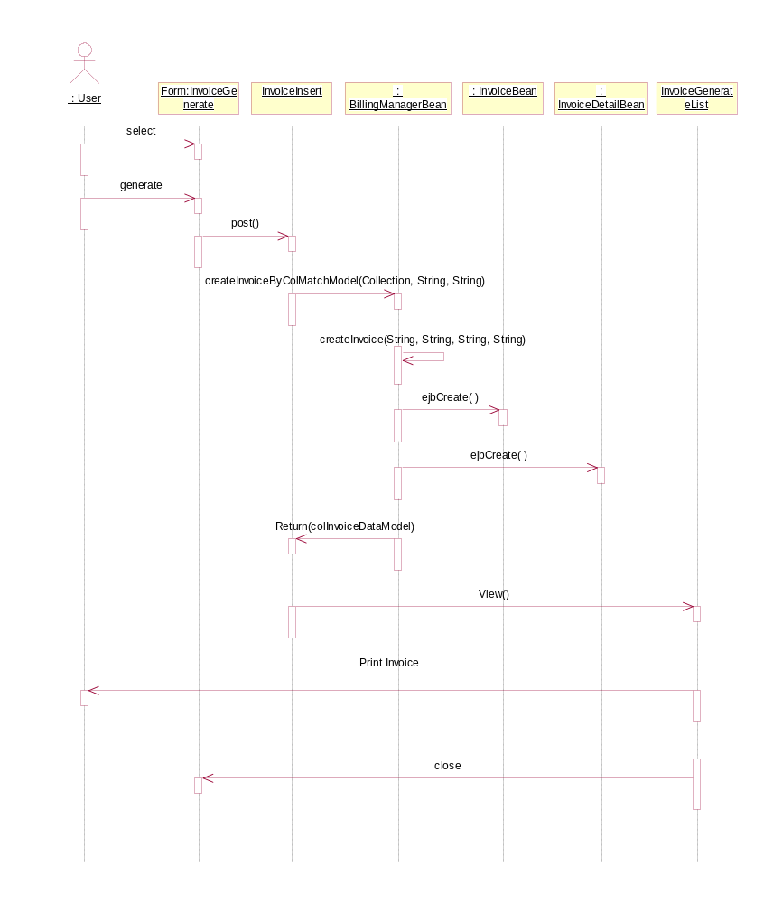
Figure 3-8 invoice generate

Generate Statement
When user want to generate statement, In the statement generate form, input criteria (Trucking id, Match Number, delivery date from to ), and click search, will list all interrelated match records, which have been approved or generated invoice; then click generate, system will pack all match information into a ApproveMatchModel, and transfer session bean BillingManager’s createStatementData method to generate several statement base on different trucker company; In method createStatementData, it will transfer entity bean statementDataBean ejbCreate() method to add statement data to database, and transfer entity bean statementDataDetailBean ejbCreate() method to add statement detail data to database .

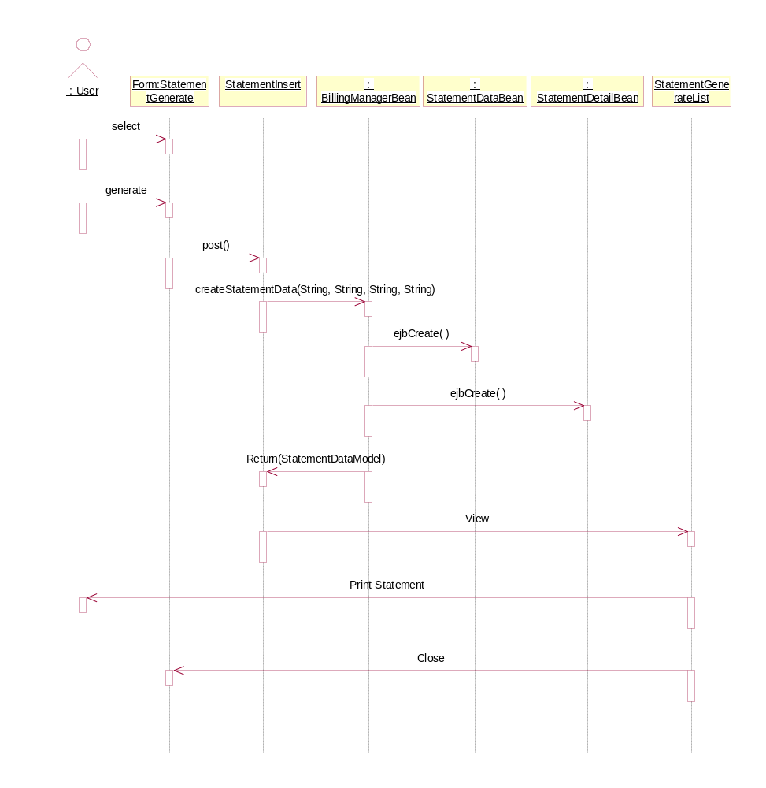
Figure 3-9 statement generate

Message Query (I think it should be “Queue”)

Summary:
The Transport Link MQ (Message Queue) process programs contain the Java classes that convert data, which receive from the IBM MQSeries5.1 (Have used IBM MQSeries 5.0 in session 2.1.1, which one is really used?), to store into Transport Link database. IBM’s MQSeries classes for Java (includes ibm-mqjms.jar, ibm-mq.jar ibm-jms.jar), and Oracle’s xmlparserv2.jar are the cornerstone of These JavaBeans receiving and parsing XML data. Parsed data stores into Transport Link database through invoked Transport Link classes’ method (which method?).

Request and Design
Transport Link uses IBM MQSeries as MS middleware to receive and process data that come from another system of LINE. These programs are designed to provide MQ data and converting and storing. It is important that received data format must accord with standard (which standard? Does it mean the DTD?).
According request, Design and provide the following classes:
- By a system properties configuration document, Transport Link defines configuration Message Queue. (Details? Or it may contain in the details of Deployment Document)
- By CBTXMLProcess class encapsulates XML data process method. (Details? What is the method? How do they handle the data processing)
- By CBTXMLConstant class defines some XML datas must be unified.
- By CBTParser class parse XML data.
- By ConfigManager class implements loading properties from configuration file.
- By LogManager class implement MQ events log
- By CBTMQListener class provides listener which listen MQ message events and invokes corresponded methods.(what is the corresponded methods?)
- By CBTMessageSet class implements starting CBTMQListener thread as a monitor.

Work flow chart
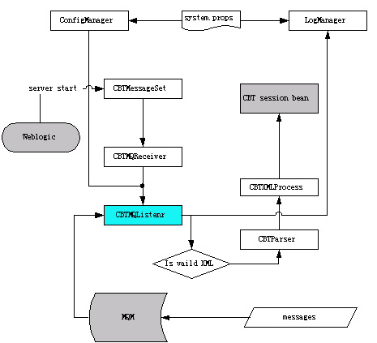
Transprot Link MQ Process Programs work flow chart
In the properties file of Weblogic configuration, add the CBTMessageSet class as a weblogic.system.startupClass. When web server service starts up, the application automates the startup of a monitor to listen messages of MQ. As soon as message data is coming, monitor trigger relevant events to process these messages, and log these process into log file.

Program specification: (Should be in more details)

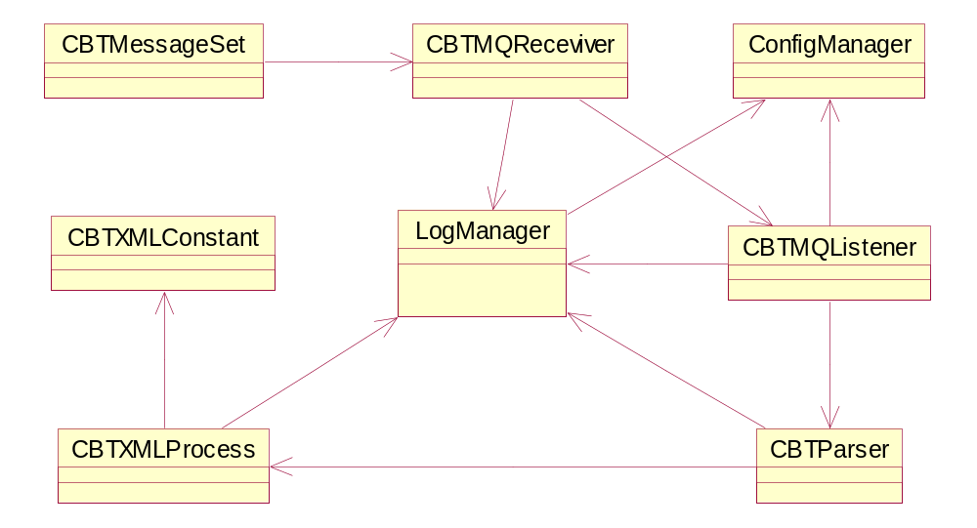
Classes’ relations UML chart

Classes specification:
CBTMessageSet: This class is a application to start receive thread as a MQSeries message monitor.
CBTMQReceviver: The class is a thread that invokes CBTMQListener to listen MQSeries.
CBTMQListener: This class is a MQSeries message monitor, which contains connecting MQ, Message receive trigger, and dealing with message data..
CBTParser: This class is a parser for parsing XML data that comes from MQ. The class uses Oracle XML SAX parser.
CBTXMLConstant: This class defines some constants for confirming XML datas must be unified
CBTXMLProcess: This class encapsulates XML data process.
ConfigManager: This class is a configuration manager. Use it implement loading properties from configuration file,
LogManager: This class implement MQ events log, Properties of log is defined at system.props file. Use ConfigManager to load them.

Security Control

Summary
When a user wants to login our system, he/she must be authenticated. And when a user wants to do an operation on our system, we will check if he/she has the right to do it. And so on, to control these cases, we define a session bean, named SecurityManager. It uses some method in SystemHelp.jar and System.jar, which you gave us. We define such as login_ authentication in WebOperator.java.

Class Description

It is much like the thing in the functional Requirement, but few information in the system design.

3.5.2.1 SecurityManager.java’s methods and functions:
Main function include:
create a company code, delete a company code, create a company’s user, suspend a company’s user, active a company’s user, change a company’s user’s password ,which is encrypted, delete a company’s user, update a company’s user’s information, remove a group from groups, remove a user from a group, Add a CBTB user to some groups, create a CBTB user, find groups, which a user is belong to, remove a user from remove a CBTB group from CBTB groups

3.5.2.2 WebOperator.java’s methods and functions :
Main function include:
Login, check Permission, clear Permission Context, front Login, logout, put Permission Context, TL Front Login (authenticate a user comes from Transport Link with a encrypted Password)

Some module of Security Control (Why Some?)

3.5.3.1 login
There are three model of login : backend ,front ,backend user SU

3.5.3.1.1 backend login
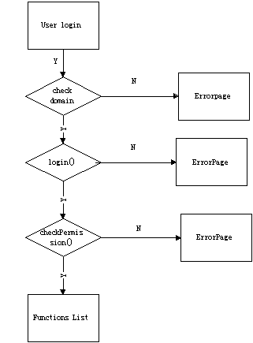
When a user is login, first we check if he/she is a CBTB user, if not ,go to the errorpage, throw a exception, and then we check his/her userid , password, if it is failed, then go to the errorpage and throw a exception. ( Don’t understand what is it talking about) After this we check his/her permission ,and list the functions that he/her can does.

3.5.3.1.2 front login
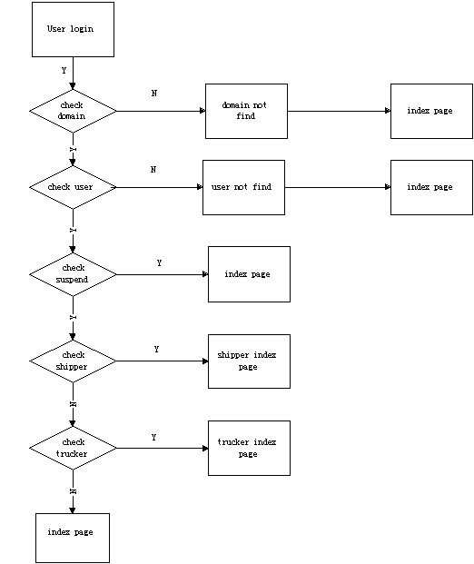
When a user is login, we check his/her domain, if the domain does not find in our database, notice he/she the domain not find and go to the index page , then we check if the userid is exist in the domain, if not ,notice he/she the userid not find and go to the index page , after this, we check if the userid have been suspended or is in registration or in black list, if it does ,go to the index page. After these check, we see if the user is a shipper or trucker, then go to them own index page : index for Shipping, index for Trucking.

3.5.3.1.3 backend user SU
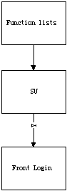
If a CBTB user has the right to SU a company user , he/she can find the function list in his/her function lists, when he/she click the SU , and input the company id and userid we send then to a front verify page, just as a front login case ,but does not have a password yet .

3.5.3.2 create user
There are two kind users to create : company users, CBTB users(operator)

3.5.3.2.1 create a company user
The function does not use in the phase I.
In our system, we define a company super user can create the company’s operator, we also define the number of operators that a company can has.

3.5.3.2.2 create a CBTB user
If a CBTB user has the right to create a CBTB user, the function will be listed in his/her function lists. When he/she click the function link, all CBTB users will be listed in the page, he/she can create a new CBTB user, can modify a existed user.
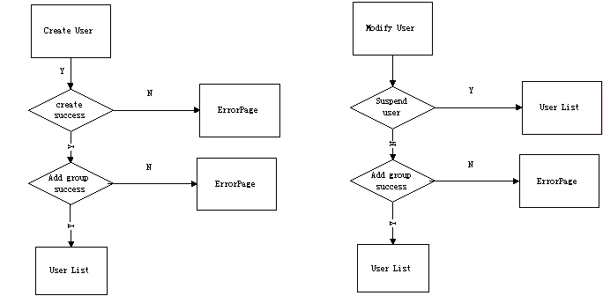

Report

Summary
The system use Jreport server to generate report, so we design report display format and data catalog in Jreport professional, and deploy them to Jreport Server. When we want to view report, we must use servlets to visit the jreport server via http protocol, and get result to display in screen ,the result type is PDF.

System Architecture

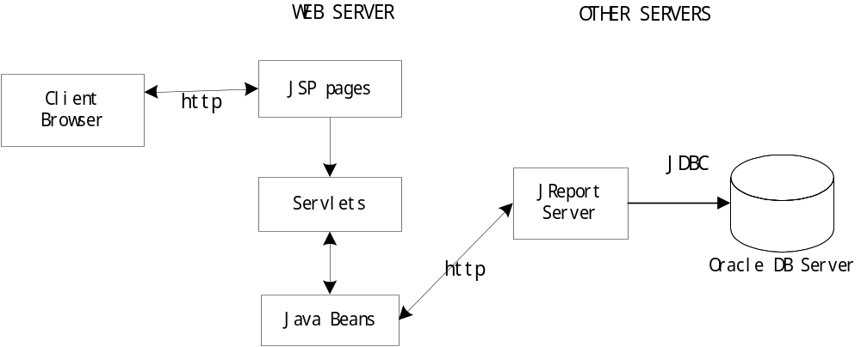
When we want generate report, first input criteria in JSP page, then jsp page will transfer servlet and append criteria, the servlet will transfer javabean (reportSpec class), the javabean will visit Jreport server via http protocol. The Jreport generate report result ,back to javabean, servlets, finally display the result in PDF format.

Format Design
In Jreport professional define the catalog name as cbt.cat, set the connection via JDBC, then define Queries which will be used in each report, the design process include define data source select table, define relations between table, select columns. Then design the display format, each report correspond to one format, files include report01a.cls, report01b.cls, report02.cls, report03. cls, report04.cls, report05.cls, report06.cls, report07.cls, report08.cls, service.cls, invoice.cls, servicePrint.cls, invoicePrint.cls.( should state clear what is it?)

Program Design
In the system use servlets to visit the jreport server via http protocol, there are based on package net.line.fortress.apps.system.report which provided by LINE.
For each report ,.must design one servlet: Report01a, Report01b, Report02a, Report02b, Report03, Report04a, Report04b, Report05, Report06, Report07, Report08,
For invoice and service report ,there are Invoice.class, ServiceReport.class to generate single item, and InvoicePrint, ServicePrint to generate multi item；

Database
It is not an updated version, and should have description on it!!!
What the tables used for? How it relate to session 3.3 Dynamic Model (that is when a business action take place, how, when and what database process will be carried out)

DataBase Diagram

Company Profile
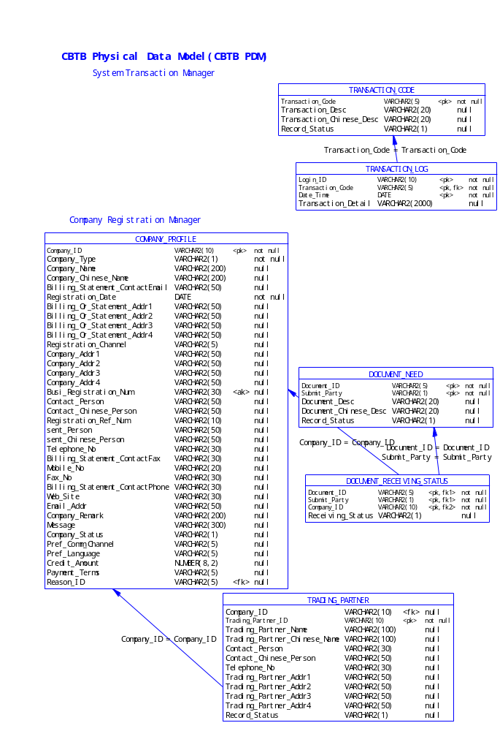

Master data
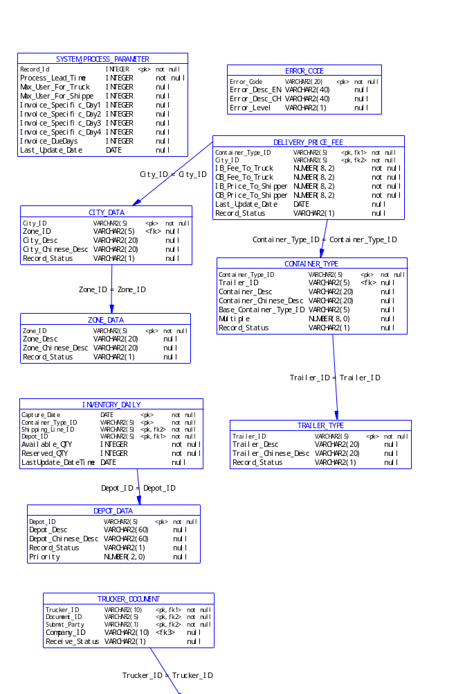

Delivery Request & Invoice

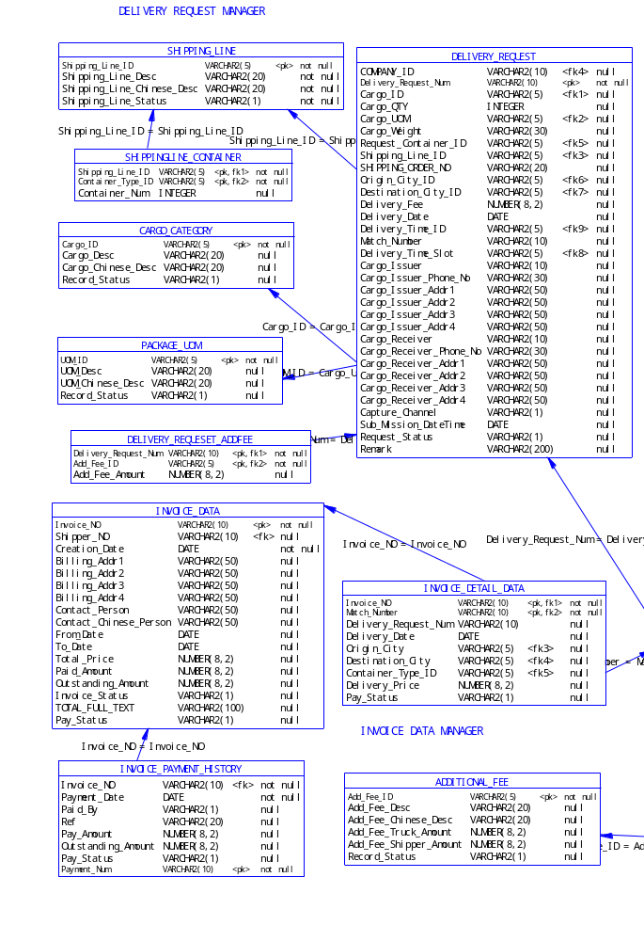

Truck Capacity & Statement

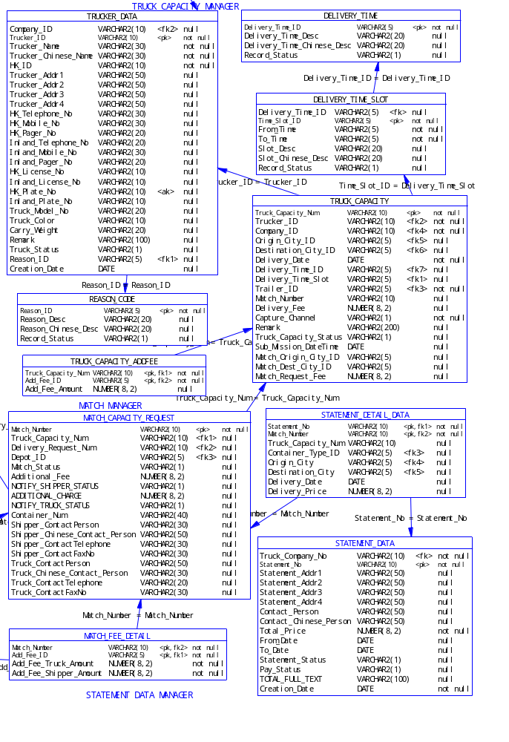

DataBase Table Structure

Table ADDITIONAL_FEE
Code | Data Type | Mandatory | Primary | Foreign Key
Add_Fee_ID | VARCHAR2(5) | TRUE | TRUE | FALSE
Add_Fee_Desc | VARCHAR2(20) | FALSE | FALSE | FALSE
Add_Fee_Chinese_Desc | VARCHAR2(20) | FALSE | FALSE | FALSE
Add_Fee_Truck_Amount | NUMBER(8,2) | FALSE | FALSE | FALSE
Add_Fee_Shipper_Amount | NUMBER(8,2) | FALSE | FALSE | FALSE
Record_Status | VARCHAR2(1) | FALSE | FALSE | FALSE

Table CARGO_CATEGORY
Code | Data Type | Mandatory | Primary | Foreign Key
Cargo_ID | VARCHAR2(5) | TRUE | TRUE | FALSE
Cargo_Desc | VARCHAR2(20) | FALSE | FALSE | FALSE
Cargo_Chinese_Desc | VARCHAR2(20) | FALSE | FALSE | FALSE
Record_Status | VARCHAR2(1) | FALSE | FALSE | FALSE

Table CITY_DATA
Code | Data Type | Mandatory | Primary | Foreign Key
City_ID | VARCHAR2(5) | TRUE | TRUE | FALSE
Zone_ID | VARCHAR2(5) | FALSE | FALSE | TRUE
City_Desc | VARCHAR2(20) | FALSE | FALSE | FALSE
City_Chinese_Desc | VARCHAR2(20) | FALSE | FALSE | FALSE
Record_Status | VARCHAR2(1) | FALSE | FALSE | FALSE

Table COMPANY_PROFILE
Code | Data Type | Mandatory | Primary | Foreign Key
Company_ID | VARCHAR2(10) | TRUE | TRUE | FALSE
Company_Type | VARCHAR2(1) | TRUE | FALSE | FALSE
Company_Name | VARCHAR2(100) | FALSE | FALSE | FALSE
Company_Chinese_Name | VARCHAR2(100) | FALSE | FALSE | FALSE
Billing_Statement_ContactEmail | VARCHAR2(30) | FALSE | FALSE | FALSE
Registration_Date | DATE | TRUE | FALSE | FALSE
Billing_Or_Statement_Addr | VARCHAR2(200) | TRUE | FALSE | FALSE
Registration_Channel | VARCHAR2(5) | FALSE | FALSE | FALSE
Company_Addr1 | VARCHAR2(150) | TRUE | FALSE | FALSE
Company_Addr2 | VARCHAR2(150) | TRUE | FALSE | FALSE
Company_Addr3 | VARCHAR2(150) | TRUE | FALSE | FALSE
Company_Addr4 | VARCHAR2(150) | TRUE | FALSE | FALSE
Busi_Registration_Num | VARCHAR2(30) | TRUE | FALSE | FALSE
Contact_Person | VARCHAR2(30) | FALSE | FALSE | FALSE
Contact_Chinese_Person | VARCHAR2(30) | FALSE | FALSE | FALSE
Registration_Ref_Num | VARCHAR2(10) | TRUE | FALSE | FALSE
Billing_Statement_Sent_Person | VARCHAR2(30) | TRUE | FALSE | FALSE
Telephone_No | VARCHAR2(20) | TRUE | FALSE | FALSE
Billing_Statement_ContactFaxNu | VARCHAR2(20) | FALSE | FALSE | FALSE
Mobile_No | VARCHAR2(20) | FALSE | FALSE | FALSE
Fax_No | VARCHAR2(20) | FALSE | FALSE | FALSE
Billing_Statement_ContactPhone | VARCHAR2(20) | FALSE | FALSE | FALSE
Web_Site | VARCHAR2(30) | FALSE | FALSE | FALSE
Email_Addr | VARCHAR2(30) | FALSE | FALSE | FALSE
Company_Remark | VARCHAR2(200) | FALSE | FALSE | FALSE
Message | VARCHAR2(300) | FALSE | FALSE | FALSE
Company_Status | VARCHAR2(1) | TRUE | FALSE | FALSE
Pref_Comm_Channel | VARCHAR2(5) | FALSE | FALSE | FALSE
Pref_Language | VARCHAR2(5) | FALSE | FALSE | FALSE
Credit_Amount | NUMBER(8,2) | FALSE | FALSE | FALSE
Payment_Terms | VARCHAR2(5) | FALSE | FALSE | FALSE
Reason_ID | VARCHAR2(5) | FALSE | FALSE | TRUE
Modify _Date | DATE | FALSE | FALSE | FALSE

Table CONTAINER_TYPE
Code | Data Type | Mandatory | Primary | Foreign Key
Container_Type_ID | VARCHAR2(5) | TRUE | TRUE | FALSE
Trailer_ID | VARCHAR2(5) | FALSE | FALSE | TRUE
Container_Desc | VARCHAR2(20) | FALSE | FALSE | FALSE
Container_Chinese_Desc | VARCHAR2(20) | FALSE | FALSE | FALSE
Base_Container_Type_ID | VARCHAR2(5) | FALSE | FALSE | FALSE
Multiple | NUMBER | FALSE | FALSE | FALSE
Record_Status | VARCHAR2(1) | FALSE | FALSE | FALSE

Table DELIVERY_PRICE_FEE
Code | Data Type | Mandatory | Primary | Foreign Key
Container_Type_ID | VARCHAR2(5) | TRUE | TRUE | TRUE
City_ID | VARCHAR2(5) | TRUE | TRUE | TRUE
IB_Fee_To_Truck | NUMBER(8,2) | TRUE | FALSE | FALSE
OB_Fee_To_Truck | NUMBER(8,2) | TRUE | FALSE | FALSE
IB_Price_To_Shipper | NUMBER(8,2) | TRUE | FALSE | FALSE
OB_Price_To_Shipper | NUMBER(8,2) | TRUE | FALSE | FALSE
Last_Update_Date | DATE | FALSE | FALSE | FALSE
Record_Status | VARCHAR2(1) | FALSE | FALSE | FALSE

Table DELIVERY_REQUESET_ADDFEE
Code | Data Type | Mandatory | Primary | Foreign Key
Deliver_Request_Num | VARCHAR2(10) | TRUE | TRUE | TRUE
Add_Fee_ID | VARCHAR2(5) | TRUE | TRUE | TRUE
Add_Fee_Amount | NUMBER(8,2) | FALSE | FALSE | FALSE
Modify _Date | DATE | FALSE | FALSE | FALSE

Table DELIVERY_REQUEST
Code | Data Type | Mandatory | Primary | Foreign Key
COMPANY_ID | VARCHAR2(10) | FALSE | FALSE | TRUE
Deliver_Request_Num | VARCHAR2(10) | TRUE | TRUE | FALSE
Cargo_ID | VARCHAR2(5) | FALSE | FALSE | TRUE
Cargo_QTY | INTEGER | TRUE | FALSE | FALSE
Cargo_UOM | VARCHAR2(5) | FALSE | FALSE | TRUE
Cargo_Weight | VARCHAR2(30) | TRUE | FALSE | FALSE
Request_Container_ID | VARCHAR2(5) | FALSE | FALSE | TRUE
Shipping_Line_ID | VARCHAR2(5) | FALSE | FALSE | TRUE
Shipping_Order_No | VARCHAR2(20) | FALSE | FALSE | FALSE
Origin_City_ID | VARCHAR2(5) | FALSE | FALSE | TRUE
Destination_City_ID | VARCHAR2(5) | FALSE | FALSE | TRUE
Delivery_Fee | NUMBER(8,2) | FALSE | FALSE | FALSE
Delivery_Date | DATE | TRUE | FALSE | FALSE
Delivery_Time_ID | VARCHAR2(5) | FALSE | FALSE | TRUE
Match_Number | VARCHAR2(10) | FALSE | FALSE | FALSE
Delivery_Time_Slot | VARCHAR2(5) | FALSE | FALSE | TRUE
Cargo_Issuer | VARCHAR2(150) | TRUE | FALSE | FALSE
Cargo_Issuer_Phone_No | VARCHAR2(20) | TRUE | FALSE | FALSE
Cargo_Issuer_Addr1 | VARCHAR2(150) | TRUE | FALSE | FALSE
Cargo_Issuer_Addr2 | VARCHAR2(150) | TRUE | FALSE | FALSE
Cargo_Issuer_Addr3 | VARCHAR2(150) | TRUE | FALSE | FALSE
Cargo_Issuer_Addr4 | VARCHAR2(150) | TRUE | FALSE | FALSE
Cargo_Receiver | VARCHAR2(150) | TRUE | FALSE | FALSE
Cargo_Receiver_Phone_No | VARCHAR2(20) | TRUE | FALSE | FALSE
Cargo_Receiver_Addr1 | VARCHAR2(150) | TRUE | FALSE | FALSE
Cargo_Receiver_Addr2 | VARCHAR2(150) | TRUE | FALSE | FALSE
Cargo_Receiver_Addr3 | VARCHAR2(150) | TRUE | FALSE | FALSE
Cargo_Receiver_Addr4 | VARCHAR2(150) | TRUE | FALSE | FALSE
Capture_Channel | VARCHAR2(1) | TRUE | FALSE | FALSE
Sub_Mission_DateTime | DATE | FALSE | FALSE | FALSE
Request_Status | VARCHAR2(1) | TRUE | FALSE | FALSE
Remark | VARCHAR2(200) | TRUE | FALSE | FALSE
Modify _Date | DATE | FALSE | FALSE | FALSE

Table DELIVERY_TIME
Code | Data Type | Mandatory | Primary | Foreign Key
Delivery_Time_ID | VARCHAR2(5) | TRUE | TRUE | FALSE
Delivery_Time_Desc | VARCHAR2(20) | FALSE | FALSE | FALSE
Delivery_Time_Chinese_Desc | VARCHAR2(20) | FALSE | FALSE | FALSE
Record_Status | VARCHAR2(1) | FALSE | FALSE | FALSE

Table DELIVERY_TIME_SLOT
Code | Data Type | Mandatory | Primary | Foreign Key
Delivery_Time_ID | VARCHAR2(5) | FALSE | FALSE | TRUE
Time_Slot_ID | VARCHAR2(5) | TRUE | TRUE | FALSE
From_Time | VARCHAR2(5) | TRUE | FALSE | FALSE
To_Time | VARCHAR2(5) | TRUE | FALSE | FALSE
Slot_Desc | VARCHAR2(20) | FALSE | FALSE | FALSE
Record_Status | VARCHAR2(1) | FALSE | FALSE | FALSE

Table DEPOT_DATA
Code | Data Type | Mandatory | Primary | Foreign Key
Depot_ID | VARCHAR2(5) | TRUE | TRUE | FALSE
Depot_Desc | VARCHAR2(60) | FALSE | FALSE | FALSE
Depot_Chinese_Desc | VARCHAR2(60) | FALSE | FALSE | FALSE
Record_Status | VARCHAR2(1) | FALSE | FALSE | FALSE

Table DOCUMENT_NEED
Code | Data Type | Mandatory | Primary | Foreign Key
Document_ID | VARCHAR2(5) | TRUE | TRUE | FALSE
Submit_Party | VARCHAR2(1) | FALSE | FALSE | FALSE
Document_Desc | VARCHAR2(20) | FALSE | FALSE | FALSE
Document_Chinese_Desc | VARCHAR2(20) | FALSE | FALSE | FALSE
Record_Status | VARCHAR2(1) | FALSE | FALSE | FALSE

Table DOCUMENT_RECEIVING_STATUS
Code | Data Type | Mandatory | Primary | Foreign Key
Document_ID | VARCHAR2(5) | TRUE | TRUE | TRUE
Company_ID | VARCHAR2(10) | TRUE | TRUE | TRUE
Receiving_Status | VARCHAR2(1) | FALSE | FALSE | FALSE
Modify _Date | DATE | FALSE | FALSE | FALSE

Table INVENTORY_DAILY
Code | Data Type | Mandatory | Primary | Foreign Key
Capture_Date | DATE | TRUE | TRUE | FALSE
Container_Type_ID | VARCHAR2(5) | TRUE | TRUE | TRUE
Shipping_Line_ID | VARCHAR2(5) | TRUE | TRUE | TRUE
Depot_ID | VARCHAR2(5) | TRUE | TRUE | TRUE
Available_QTY | INTEGER | TRUE | FALSE | FALSE
Reserved_QTY | INTEGER | TRUE | FALSE | FALSE
LastUpdate_DateTime | DATE | FALSE | FALSE | FALSE
Modify _Date | DATE | FALSE | FALSE | FALSE

Table INVOICE_DATA
Code | Data Type | Mandatory | Primary | Foreign Key
Invoice_NO | VARCHAR2(10) | TRUE | TRUE | FALSE
Shipper_NO | VARCHAR2(10) | FALSE | FALSE | TRUE
Creation_Date | DATE | TRUE | FALSE | FALSE
Billing_Addr1 | VARCHAR2(150) | TRUE | FALSE | FALSE
Billing_Addr2 | VARCHAR2(150) | TRUE | FALSE | FALSE
Billing_Addr3 | VARCHAR2(150) | TRUE | FALSE | FALSE
Billing_Addr4 | VARCHAR2(150) | TRUE | FALSE | FALSE
Contact_Person | VARCHAR2(30) | TRUE | FALSE | FALSE
From_Date | DATE | FALSE | FALSE | FALSE
To_Date | DATE | FALSE | FALSE | FALSE
Total_Price | NUMBER(8,2) | TRUE | FALSE | FALSE
Paid_Amount | NUMBER(8,2) | FALSE | FALSE | FALSE
Outstanding_Amount | NUMBER(8,2) | FALSE | FALSE | FALSE
Invoice_Status | VARCHAR2(1) | FALSE | FALSE | FALSE
Total_All_Text | VARCHAR2(100) | FALSE | FALSE | FALSE
Pay_Status | VARCHAR2(1) | FALSE | FALSE | FALSE
Modify _Date | DATE | FALSE | FALSE | FALSE

Table INVOICE_DETAIL_DATA
Code | Data Type | Mandatory | Primary | Foreign Key
Invoice_NO | VARCHAR2(10) | TRUE | TRUE | TRUE
Match_Number | VARCHAR2(10) | TRUE | TRUE | TRUE
Deliver_Request_Num | VARCHAR2(10) | FALSE | FALSE | FALSE
Delivery_Date | DATE | FALSE | FALSE | FALSE
Origin_City | VARCHAR2(5) | FALSE | FALSE | TRUE
Destination_City | VARCHAR2(5) | FALSE | FALSE | TRUE
Container_Type_ID | VARCHAR2(5) | FALSE | FALSE | TRUE
Delivery_Price | NUMBER(8,2) | FALSE | FALSE | FALSE
Pay_Status | VARCHAR2(1) | FALSE | FALSE | FALSE
Modify _Date | DATE | FALSE | FALSE | FALSE

Table INVOICE_PAYMENT_HISTORY
Code | Data Type | Mandatory | Primary | Foreign Key
Invoice_NO | VARCHAR2(10) | TRUE | TRUE | TRUE
Payment_Date | DATE | TRUE | TRUE | FALSE
Paid_By | VARCHAR2(1) | FALSE | FALSE | FALSE
Ref | VARCHAR2(20) | FALSE | FALSE | FALSE
Pay_Amount | NUMBER(8,2) | FALSE | FALSE | FALSE
Outstanding_Amount | NUMBER(8,2) | FALSE | FALSE | FALSE
Pay_Status | VARCHAR2(1) | FALSE | FALSE | FALSE
Modify _Date | DATE | FALSE | FALSE | FALSE

Table MATCH_CAPACITY_REQUEST
Code | Data Type | Mandatory | Primary | Foreign Key
Match_Number | VARCHAR2(10) | TRUE | TRUE | FALSE
Truck_Capacity_Num | VARCHAR2(10) | FALSE | FALSE | TRUE
Deliver_Request_Num | VARCHAR2(10) | FALSE | FALSE | TRUE
Depot_ID | VARCHAR2(5) | FALSE | FALSE | TRUE
Match_Status | VARCHAR2(1) | FALSE | FALSE | FALSE
Additional_Fee | NUMBER(8,2) | FALSE | FALSE | FALSE
Notify_Shipper_Status | VARCHAR2(1) | FALSE | FALSE | FALSE
Additional_Charge | NUMBER(8,2) | FALSE | FALSE | FALSE
Notify_Truck_Status | VARCHAR2(1) | FALSE | FALSE | FALSE

Table MATCH_FEE_DETAIL
Code | Data Type | Mandatory | Primary | Foreign Key
Match_Number | VARCHAR2(10) | TRUE | TRUE | TRUE
Add_Fee_ID | VARCHAR2(5) | TRUE | TRUE | TRUE
Add_Fee_Truck_Amount | NUMBER(8,2) | TRUE | FALSE | FALSE
Add_Fee_Shipper_Amount | NUMBER(8,2) | TRUE | FALSE | FALSE

Table PACKAGE_UOM
Code | Data Type | Mandatory | Primary | Foreign Key
UOM_ID | VARCHAR2(5) | TRUE | TRUE | FALSE
UOM_Desc | VARCHAR2(20) | FALSE | FALSE | FALSE
UOM_Chinese_Desc | VARCHAR2(20) | FALSE | FALSE | FALSE
Record_Status | VARCHAR2(1) | FALSE | FALSE | FALSE

Table REASON_CODE
Code | Data Type | Mandatory | Primary | Foreign Key
Reason_ID | VARCHAR2(5) | TRUE | TRUE | FALSE
Reason_Desc | VARCHAR2(20) | FALSE | FALSE | FALSE
Reason_Chinese_Desc | VARCHAR2(20) | FALSE | FALSE | FALSE
Record_Status | VARCHAR2(1) | FALSE | FALSE | FALSE

Table SHIPPINGLINE_CONTAINER
Code | Data Type | Mandatory | Primary | Foreign Key
Inventory_Date | DATE | TRUE | TRUE | TRUE
Shipping_Line_ID | VARCHAR2(5) | TRUE | TRUE | TRUE
Container_Type_ID | VARCHAR2(5) | TRUE | TRUE | TRUE
Container_Num | INTEGER | FALSE | FALSE | FALSE
Modify _Date | DATE | FALSE | FALSE | FALSE

Table SHIPPING_LINE
Code | Data Type | Mandatory | Primary | Foreign Key
Shipping_Line_ID | VARCHAR2(5) | TRUE | TRUE | FALSE
Shipping_Line_Desc | VARCHAR2(20) | TRUE | FALSE | FALSE
Shipping_Line_Chinese_Desc | VARCHAR2(20) | TRUE | FALSE | FALSE
Shipping_Line_Status | VARCHAR2(1) | TRUE | FALSE | FALSE

Table STATEMENT_DATA
Code | Data Type | Mandatory | Primary | Foreign Key
Truck_Company_No | VARCHAR2(10) | TRUE | FALSE | TRUE
Statement_No | VARCHAR2(10) | TRUE | TRUE | FALSE
Statement_Addr1 | VARCHAR2(150) | FALSE | FALSE | FALSE
Statement_Addr2 | VARCHAR2(150) | FALSE | FALSE | FALSE
Statement_Addr3 | VARCHAR2(150) | FALSE | FALSE | FALSE
Statement_Addr4 | VARCHAR2(150) | FALSE | FALSE | FALSE
Contact_Person | VARCHAR2(30) | FALSE | FALSE | FALSE
Total_Price | NUMBER(8,2) | TRUE | FALSE | FALSE
From_Date | DATE | FALSE | FALSE | FALSE
To_Date | DATE | FALSE | FALSE | FALSE
Statement_Status | VARCHAR2(1) | FALSE | FALSE | FALSE
Pay_Status | VARCHAR2(1) | FALSE | FALSE | FALSE
Total_Full_Text | VARCHAR2(100) | FALSE | FALSE | FALSE
Creation_Date | DATE | TRUE | FALSE | FALSE
Modify _Date | DATE | FALSE | FALSE | FALSE

Table STATEMENT_DETAIL_DATA
Code | Data Type | Mandatory | Primary | Foreign Key
Statement_No | VARCHAR2(10) | TRUE | TRUE | TRUE
Match_Number | VARCHAR2(10) | TRUE | TRUE | TRUE
Truck_Capacity_Num | VARCHAR2(10) | FALSE | FALSE | FALSE
Container_Type_ID | VARCHAR2(5) | FALSE | FALSE | TRUE
Origin_City | VARCHAR2(5) | FALSE | FALSE | TRUE
Destination_City | VARCHAR2(5) | FALSE | FALSE | TRUE
Delivery_Date | DATE | FALSE | FALSE | FALSE
Delivery_Price | NUMBER(8,2) | FALSE | FALSE | FALSE
Modify _Date | DATE | FALSE | FALSE | FALSE

Table SYSTEM_PROCESS_PARAMETER
Code | Data Type | Mandatory | Primary | Foreign Key
Record_Id | INTEGER | TRUE | TRUE | FALSE
Process_Lead_Time | NUMBER(8,2) | TRUE | FALSE | FALSE
Max_User_For_Truck | INTEGER | TRUE | FALSE | FALSE
Max_User_For_Shippe | INTEGER | TRUE | FALSE | FALSE
Invoice_Specific_Day | INTEGER | TRUE | FALSE | FALSE
Last_Update_Date | DATE | FALSE | FALSE | FALSE

Table TRADING_PARTNER
Code | Data Type | Mandatory | Primary | Foreign Key
Company_ID | VARCHAR2(10) | FALSE | FALSE | TRUE
Trading_Partner_ID | VARCHAR2(10) | TRUE | TRUE | FALSE
Trading_Partner_Name | VARCHAR2(100) | TRUE | FALSE | FALSE
Trading_Partner_Chinese_Name | VARCHAR2(100) | TRUE | FALSE | FALSE
Contact_Person | VARCHAR2(30) | FALSE | FALSE | FALSE
Telephone_No | VARCHAR2(20) | FALSE | FALSE | FALSE
Trading_Partner_Addr1 | VARCHAR2(150) | FALSE | FALSE | FALSE
Trading_Partner_Addr2 | VARCHAR2(150) | FALSE | FALSE | FALSE
Trading_Partner_Addr3 | VARCHAR2(150) | FALSE | FALSE | FALSE
Trading_Partner_Addr4 | VARCHAR2(150) | FALSE | FALSE | FALSE
Record_Status | VARCHAR2(1) | FALSE | FALSE | FALSE
Modify _Date | DATE | FALSE | FALSE | FALSE

Table TRAILER_TYPE
Code | Data Type | Mandatory | Primary | Foreign Key
Trailer_ID | VARCHAR2(5) | TRUE | TRUE | FALSE
Trailer_Desc | VARCHAR2(20) | FALSE | FALSE | FALSE
Trailer_Chinese_Desc | VARCHAR2(20) | FALSE | FALSE | FALSE
Record_Status | VARCHAR2(1) | FALSE | FALSE | FALSE

Table TRANSACTION_CODE
Code | Data Type | Mandatory | Primary | Foreign Key
Transaction_Code | VARCHAR2(5) | TRUE | TRUE | FALSE
Transaction_Desc | VARCHAR2(20) | FALSE | FALSE | FALSE
Transaction_Chinese_Desc | VARCHAR2(20) | FALSE | FALSE | FALSE
Record_Status | VARCHAR2(1) | FALSE | FALSE | FALSE

Table TRANSACTION_LOG
Code | Data Type | Mandatory | Primary | Foreign Key
Login_ID | VARCHAR2(10) | TRUE | TRUE | TRUE
Transaction_Code | VARCHAR2(5) | TRUE | TRUE | TRUE
Date_Time | DATE | TRUE | TRUE | FALSE
Transaction_Detail | VARCHAR2(2000) | FALSE | FALSE | FALSE

Table TRUCKER_DATA
Code | Data Type | Mandatory | Primary | Foreign Key
Company_ID | VARCHAR2(10) | FALSE | FALSE | TRUE
Trucker_ID | VARCHAR2(10) | TRUE | TRUE | FALSE
Trucker_Name | VARCHAR2(30) | TRUE | FALSE | FALSE
HK_ID | VARCHAR2(10) | TRUE | FALSE | FALSE
Trucker_Addr | VARCHAR2(100) | TRUE | FALSE | FALSE
HK_Telephone_No | VARCHAR2(20) | FALSE | FALSE | FALSE
HK_Mobile_No | VARCHAR2(20) | FALSE | FALSE | FALSE
HK_Pager_No | VARCHAR2(20) | FALSE | FALSE | FALSE
Inland_Telephone_No | VARCHAR2(20) | FALSE | FALSE | FALSE
Inland_Mobile_No | VARCHAR2(20) | FALSE | FALSE | FALSE
Inland_Pager_No | VARCHAR2(20) | FALSE | FALSE | FALSE
HK_License_No | VARCHAR2(10) | TRUE | FALSE | FALSE
Inland_License_No | VARCHAR2(10) | TRUE | FALSE | FALSE
HK_Plate_No | VARCHAR2(10) | TRUE | FALSE | FALSE
Inland_Plate_No | VARCHAR2(10) | FALSE | FALSE | FALSE
Truck_Model_No | VARCHAR2(20) | TRUE | FALSE | FALSE
Truck_Color | VARCHAR2(10) | TRUE | FALSE | FALSE
Carry_Weight | VARCHAR2(20) | TRUE | FALSE | FALSE
Remark | VARCHAR2(100) | FALSE | FALSE | FALSE
Truck_Status | VARCHAR2(1) | TRUE | FALSE | FALSE
Reason_ID | VARCHAR2(5) | FALSE | FALSE | TRUE
Modify _Date | DATE | FALSE | FALSE | FALSE

Table TRUCK_CAPACITY
Code | Data Type | Mandatory | Primary | Foreign Key
Truck_Capacity_Num | VARCHAR2(10) | TRUE | TRUE | FALSE
Trucker_ID | VARCHAR2(10) | FALSE | FALSE | TRUE
Company_ID | VARCHAR2(10) | TRUE | FALSE | TRUE
Origin_City_ID | VARCHAR2(5) | TRUE | FALSE | TRUE
Destination_City_ID | VARCHAR2(5) | TRUE | FALSE | TRUE
Delivery_Date | DATE | TRUE | FALSE | FALSE
Delivery_Time_ID | VARCHAR2(5) | FALSE | FALSE | TRUE
Delivery_Time_Slot | VARCHAR2(5) | TRUE | FALSE | TRUE
Trailer_ID | VARCHAR2(5) | TRUE | FALSE | TRUE
Match_Number | VARCHAR2(10) | FALSE | FALSE | FALSE
Deliver_Fee | NUMBER(8,2) | FALSE | FALSE | FALSE
Capture_Channel | VARCHAR2(1) | TRUE | FALSE | FALSE
Remark | VARCHAR2(200) | FALSE | FALSE | FALSE
Truck_Capacity_Status | VARCHAR2(1) | FALSE | FALSE | FALSE
Sub_Mission_DateTime | DATE | FALSE | FALSE | FALSE
Match_Origin_City_ID | VARCHAR2(5) | FALSE | FALSE | FALSE
Match_Dest_City_ID | VARCHAR2(5) | FALSE | FALSE | FALSE
Match_Request_Fee | NUMBER(8,2) | FALSE | FALSE | FALSE
Modify _Date | DATE | FALSE | FALSE | FALSE

Table TRUCK_CAPACITY_ADDFEE
Code | Data Type | Mandatory | Primary | Foreign Key
Truck_Capacity_Num | VARCHAR2(10) | TRUE | TRUE | TRUE
Add_Fee_ID | VARCHAR2(5) | TRUE | TRUE | TRUE
Add_Fee_Amount | NUMBER(8,2) | FALSE | FALSE | FALSE

Table ZONE_DATA
Code | Data Type | Mandatory | Primary | Foreign Key
Zone_ID | VARCHAR2(5) | TRUE | TRUE | FALSE
Zone_Desc | VARCHAR2(20) | FALSE | FALSE | FALSE
Zone_Chinese_Desc | VARCHAR2(20) | FALSE | FALSE | FALSE
Record_Status | VARCHAR2(1) | FALSE | FALSE | FALSE
Does not contain all tables in the SYSTEM!!!

Appendix:

Development Tools and Technologies
The following table summarize the development tools being used for Application Development.
 | Software
EJB/JAVA  Development | Rational Rose 2000
EJB/JAVA  Development | Jbuilder 4.0
Web Development | Macromedia Dream Waver
Database | Oracle 8.1.6 for Solaris
Jreport | JReport Professional 3.1.2
PDF Reader | Acrobat Reader 5.0

